| Career Accelerator programme: | KCL/FourthRev – Product Management Career Accelerator |
| --- | --- |
| Course Assignment: | Employer Project - Assignment 3: Final Report & Presentation |
| Learner Name: | Team 3 [Mosaic]:  Lina Gusso  Chinenye Stella Egeolu  Paul Barrow  Pavan Rauli  Yemi Aroyewun |
| Final word count:  (excluding references and formatting text) | 1,747 |
| Submission date: | 27-Aug-2024 |

Learner Declaration

By submitting this assignment, I confirm that I understand the programme's Academic Policies and Procedures and Plagiarism Regulations. The material contained in this assignment is my own work unless otherwise acknowledged, and that to the best of my knowledge, I have not committed acts of plagiarism in my work.

I acknowledge that it is my responsibility to ensure that any submission is within the permitted word count or time limit. I have included the accurate final word count (excluding references or formatting text such as cover sheets) on the written submission cover sheet. Images, such as prototypes, will not count towards a word count limit only if they are required as part of the 'Suggested Approach' section of an Assignment. I understand that any content that exceeds the permitted submission length will not be included in the evaluation of marks or be provided with feedback. Any submission that falls short of the permitted length may result in a penalty. I am solely responsible for adhering to the submission length and take full responsibility for any ramifications thereof.



Innovating Closed Caption Experiences  
Mosaic (Team 3)

27th August, 2024

Contents

1 Executive Summary 4

2 Research & Analysis 4

2.1 Market Analysis 4

2.2 User Analysis 5

3 Problem Statement & Ideation 5

3.1 Problem statement 6

3.2 User Persona & Ideation 6

3.3 Hypothesis 7

3.4 Assumptions 7

3.5 Statement of business value 7

4 Proposed Solution 7

4.1 Product Definition 7

4.2 Prototype 8

4.3 Product Metrics & Success Criteria 11

5 Concept Validation 11

5.1 Objective of the usability testing 11

5.2 Key Findings from testing 11

5.3 Refinement of the Companion App 12

5.4 Recommendations from Usability testing: 12

6 Recommendations 13

7 Appendices 15

7.1 Team Collaboration 15

7.1.1 Team name – Mosaic 15

7.1.2 Team Charter 16

7.1.3 Collaboration model 16

7.2 Market Research 17

7.2.1 TV Market Summary 17

7.2.2 Market Analysis 18

7.2.3 Sky TV SWOT 19

7.2.4 Closed Caption Research 20

7.2.5 Competitor Insights & Threats 21

7.2.6 Comparison of Sky Glass competitors, ranked by CC coverage and CC customisation features 22

7.2.7 Closed caption user interface competitor comparison 23

7.2.8 Competitors caption menus 25

7.2.9 Sky Glass CC SWOT Analysis 32

7.2.10 Porters Five Forces Analysis 32

7.3 User Research 33

7.3.1 User Analysis 33

7.3.2 Persona Empathy Map 34

7.3.3 Sky Communities 34

7.4 Ideation 36

7.4.1 Problem Research & Ideation 36

7.4.2 Mind mapping 37

7.4.3 Blue Sky thinking 38

7.4.4 Opportunity Solutions Tree 39

7.4.5 Riskiest assumption canvas 40

7.5 Prototype 43

7.5.1 Version 1 Caption Configuration Prototype (see Section 4 for the final prototype) 43

7.5.2 Version 1 prototype Companion App – with presets (see Section 4 for final Prototype) 44

7.5.3 Version 2 prototype Companion App – with presets (see Section 4 for final prototype) 45

7.6 User Testing 46

7.6.1 User Test Plan 46

7.6.2 Test Script 47

7.6.3 Success Criteria 49

7.6.4 Methodology of Testing 50

7.6.5 User Testing Results 51

7.6.6 Results - graphs 56

8 References 59

# Executive Summary

Our team have been tasked with proposing a Sky Glass enhancement to increase closed caption (CC) accessibility for users. Our goal was to identify key opportunities and propose a feature that delivers an enhanced user experience, which will enable further future innovation without compromising regulatory compliance.

Following user, market and competitor research, we propose launching a Sky Glass Companion App, which improves accessibility to CC features for users who struggle using traditional remote controls due to motor and/or cognitive impairment.

Prototype testing with users validated that the app enables faster and simpler control of CC settings and provided further insights for streamlining the app experience. Although we confirmed potential value for users with difficulties using a remote control, we recommend further testing with more representative target users.

Following MVP release of the Companion App, focusing on CC accessibility, there are several future enhancements we suggest Sky consider next. These will drive further innovation and inclusivity through this investment, such as consolidating support for accessibility users, and generative AI experience to enhance user configuration.

# Research & Analysis

To understand the problem context more deeply, our team broke down and distributed research needed ahead of ideation to focus on two key areas, Market and User Analysis (see Appendix 7.2 and 7.3):

## Market Analysis

* Sky remains the largest subscription-based broadcaster in the UK (Stoll, 2024a), and its audience increasingly diverse. With Ofcom’s research highlighting that 18% of the UK population has a disability, and 10% of all television viewers using subtitles daily, CC is an essential feature, and to remain truly inclusive and competitive, innovation in the area is critical.
* Sky consistently performs strongly in CC content coverage and availability. To identify opportunities for innovation, and compete more strongly, we researched across the competitive landscape, identifying several opportunities (Appendix 7.2).

## User Analysis

* Those with hearing and visual impairments remain the most known CC users, closely followed by language-learners and those with cognitive challenges who find reading content helpful.
* 80% of disabled users have experienced accessibility issues with streaming services, with 1 in 5 users cancelling their subscription as a result (Scope, 2020).
* Our research exposes additional profiles we must consider, with rapidly evolving trends introducing a broader set of viewer needs. For example, viewers with physical conditions making remote controls including the voice command button obsolete, and multitaskers who prefer subtitles as they watch TV alongside other activities:

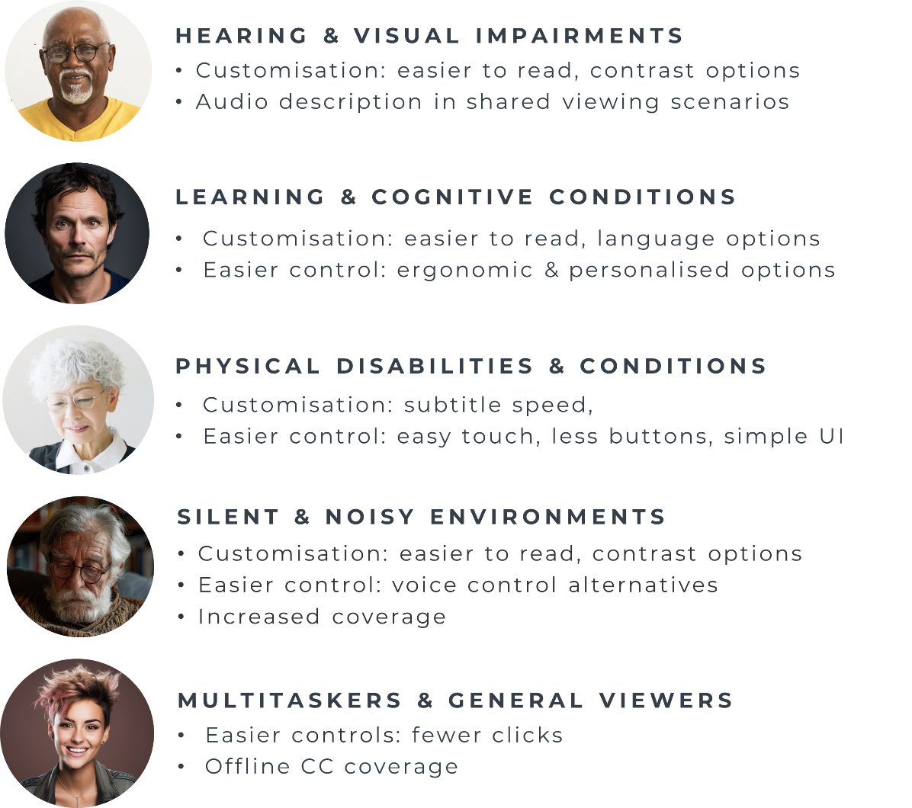

# Problem Statement & Ideation

Our research showed that to compete with the broader market, and meet the demand of the Sky audience, there were two key opportunities:

* Introducing CC customisation.
* Increasingly accessible ways to interact with Sky’s services, accessing CC configuration and other accessibility features, with the utmost ease – fewer clicks and alternatives to physical remotes.

## Problem statement

Recognising Sky's ongoing efforts to enable CC customisation, we focused our efforts on empowering Sky Glass users and their carers to seamlessly customise CCs and accessibility settings across all devices, ensuring a tailored experience for individual needs:

“How might we create a more accessible way to quickly and easily configure and customise closed caption settings for users who struggle to use a traditional remote control?”

## User Persona & Ideation

To focus our ideation, we developed our target user persona, underscoring not only the problem statement, but also captured the core preferences, challenges and frustrations faced by these users.

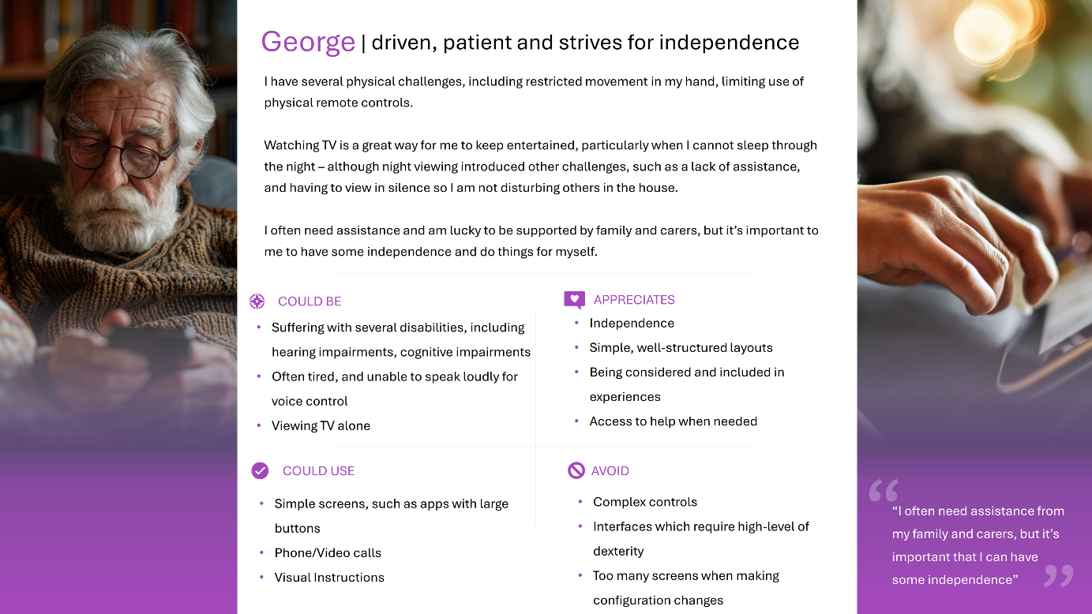

Leveraging overall research insights, problem statement and user persona, we employed various ideation techniques to arrive at four potential solutions:

* CC Customisation
* Companion App
* Improved CC User Interface
* GenAI-driven user assistance

Our idea was further refined and prioritised, using the RICE and Effort/Value models, deciding to progress with a Sky Glass Companion App (Appendix 7.4.1).

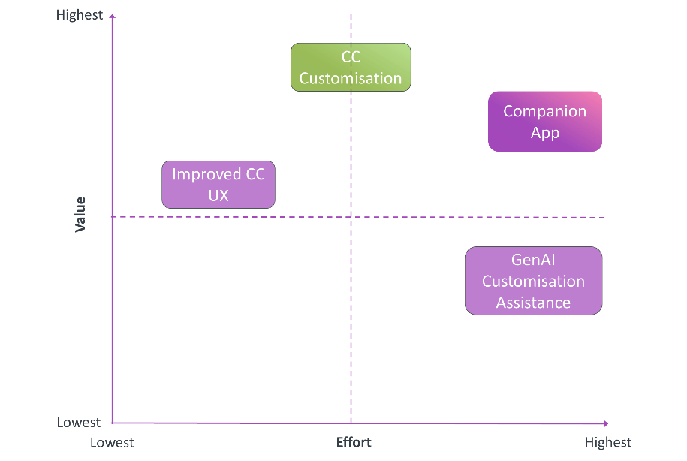

## Hypothesis

Enabling users to customise closed captions and providing them with easy to access configuration controls using a Companion App, will increase inclusivity, accessibility, and user satisfaction.

## Assumptions

* **User Adoption:** The riskiest assumption is that users with accessibility needs will be willing to utilise a secondary device (smartphone or tablet) in conjunction with their TV to manage closed captions. (Appendix 7.4.5)
* **Device Accessibility**: The app must be accessible to users with various disabilities, supporting screen readers, colour contrast, and alternative inputs.
* **Ease of Use**: The app should be intuitive and user-friendly, especially for those with cognitive or motor impairments.
* **Seamless Integration**: The app must seamlessly synchronise with the TV’s closed captioning system, ensuring a lag-free experience.
* **Customisation Options**: The app should offer a range of customisation options for closed captions to meet diverse user preferences.

## Statement of business value

The Sky Glass Companion App represents a significant business opportunity by reinforcing Sky's commitment to "Believe in Better" (Sky, 2024) through transformative advancements in accessibility and inclusivity. This commitment to inclusivity allows Sky to expand its market reach, drive growth, and position itself as an industry leader in accessible technology.

# Proposed Solution

## Product Definition

The proposed Sky Glass Companion App aims to enhance the accessibility of CC features, particularly for users with mobility, coordination, or cognitive impairments who find traditional remote controls challenging. Users can effortlessly enable and customise captions on their Sky Glass television using the app. The app's intuitive interface promotes a more inclusive experience for everyone, regardless of ability. This solution aligns with principles of Universal Design by offering benefits to a wider audience, including those who prefer simplified controls or are new to technology. By leveraging existing devices, this enhancement also contributes to sustainability efforts by reducing the need for additional electronic devices and minimising environmental impact (EC, 2012).

## Prototype

Images of the prototype are presented below. A minimal interface design provides buttons with easily recognisable icons and simple navigation to meet user needs (Louvent 2023, W3C 2023).

|  |
| --- |
| **Step 1 - Homepage:** Sky Glass Companion App displayed on a tablet, with Sky Glass on a TV screen in the background |
|  |

|  |
| --- |
| **Step 2 - Homepage:** User has enabled subtitles by pressing the highlighted app button |
|  |

|  |
| --- |
| **Step 3 - Caption format menu:** User has opened the subtitle style menu to access preset style choices. The selected format is highlighted |
|  |

|  |
| --- |
| **Step 4: Customise caption menu:** After accessing the customise format menu, text size, colour and background can be selected and saved |
|  |

|  |
| --- |
| **Prototype revised following user testing:** Caption style menu provides choice of preset format and user choice of text size, colour and background on one screen (See section 5 – Validation). |
|  |

## Product Metrics & Success Criteri**a**

To ensure the feature addresses our mission and proves our hypothesis, we chose two key metrics: content accessibility and customer satisfaction to align with the Sky Glass OKR (studentcommunity.fourthrev.com, 2024). These metrics directly support Sky's core goals, ensuring we deliver an exceptional closed-caption experience while increasing feature adoption and fostering business growth.

|  |
| --- |
| **Product metrics and success criteria hierarchy** |
|  |

**Adoption Rate** –This metric measures the active usage of the Companion App and its accessibility features. Higher adoption rates will signal that the features are providing value and addressing user needs.

**User Satisfaction** - Collecting ongoing feedback through **CSAT** Surveys and **Net Promoter Scores (NPS)** will track user sentiment and identify areas for improvement.

We will know our hypothesis is true when over 75% of regular closed caption users customise subtitles using the Companion App, and we increase CSAT and NPS in the target user population by at least 50% within two quarters of launch.

# Concept Validation

## Objective of the usability testing

Objective of the testing was to validate the usability of the customised CC and prove the desirability and benefits of utilising the Companion App for this purpose.

## Key Findings from testing

During the moderated testing, we observed the testers by recording and documenting any findings, this was crucial to validate our hypothesis and assumptions (Bland, 2023).

* **Success and error rate**: 100% of participants were able to complete their tasks, however 25% of participants struggling with navigation and certain interactions. Others made mistakes which they quickly realised and self-corrected indicating intuitive design.
* **Ease of use**: 100% participants expressed high satisfaction with overall usability of application 64% rating it excellent and 36% good. Participants expressed high satisfaction with the app’s functionality and design finding it user-friendly and intuitive.
* **Time to complete the task**: Most participants took 3 – 5 seconds to complete each task. Overall task-completion time was extremely encouraging.
* **Satisfaction ranking:** 80% participants rated the app 4 or above out of 5 for desirability highlighting its ease of use. Participants with mobility and hearing issues expressed a preference for the Companion App due to struggling with using the traditional remote, although others still prefer the remote.

## Refinement of the Companion App

Based on user feedback gathered during testing, we refined the prototype afterwards primarily focussing on simplifying flow between screens. Some users struggled to go back to the main menu from the preset screen after deciding not to select a preset, and others questioned where presets and customisation were on separate screens. Both were resolved in our latest prototype with consolidated screens and option to ‘Cancel’:

|  |
| --- |
| **Prototype revised following user testing** |
|  |

## Recommendations from Usability testing:

Based on the testing conducted, users recommended the following enhancements of the feature:

* **Enhance Touch Targets:** Increase the size of interactive elements, especially in customisation menus, to accommodate users with limited dexterity.
* **Increased font options:** consistent with user research, which we believe Sky is addressing.
* **Assistive Technology:** Incorporate support for technology such as screen reader, zoom effect, keyboard, AI to enhance accessibility.
* **Voice control:**  Introduce voice commands for users unable to use remote control or press screen buttons.
* **Language options:** Provide different languages for non-English speakers or users who prefer subtitles in other languages.

# Recommendations

Our user testing and validation efforts outline the exciting opportunity and user value the Sky Glass Companion App will bring. Whilst our initial focus remains on supporting innovation of CC, our ideation included potential future enhancements which drive further inclusivity innovations and increase the business value from these investments.

Next steps follow a sequence of activities ensuring the product team further validate the MVP scope through more specific research, provide initial value by focus on soft-launching features enabling faster access to CC configuration. Next, evolving the feature set to drive innovation that ensures Sky Glass delivers a truly inclusive service:

* **Deeper Research**: our user testing provided great insights to refine and enhance our solution. Deeper testing with users across a range of disabilities and impairments will be critical in ensuring the initial MVP delivers a great experience and delivers true accessibility.
* **Refine and Launch** following the additional research outcomes. Our guidance is to consider a soft launch of the app to the target users, perhaps those who use existing accessibility services.
* **Further Research** on how to combine other accessibility services with the new offering, including easier user setup and the incorporation of the Be My Eyes service.
* **Prioritisation** of future enhancements, a few of which are outlined in the high-level roadmap below.

**Now, Next, Later Roadmap**

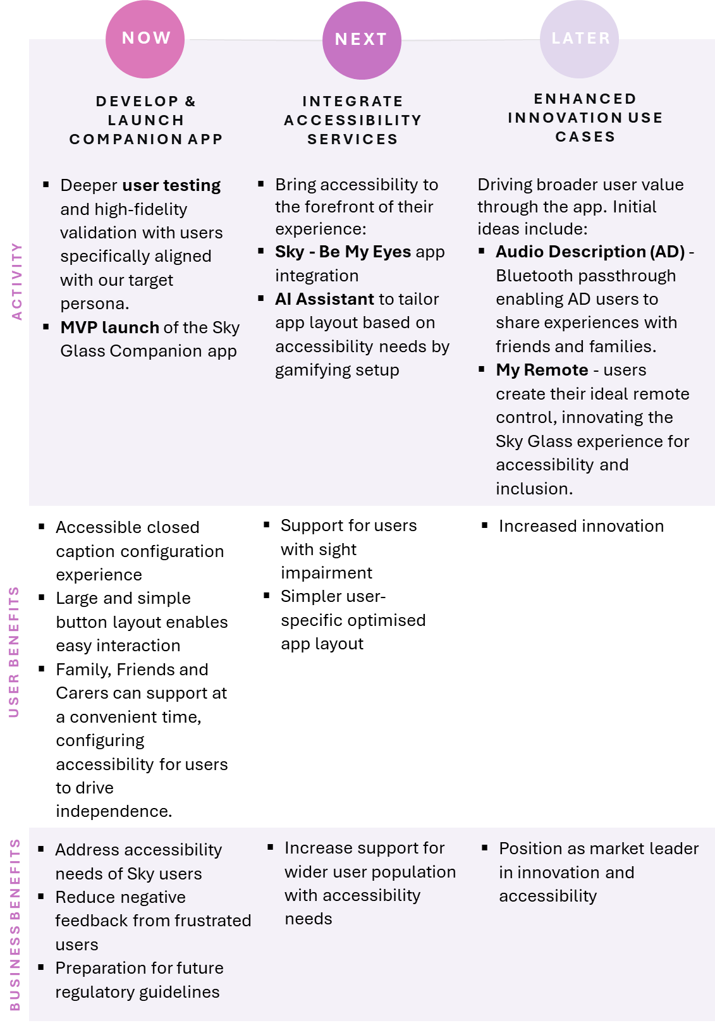

# Appendices

## Team Collaboration

### Team name – Mosaic

During the creation of our Team Charter, Team 3 focused on how our strengths could be combined to deliver the most value to the Sky Group and the Sky Glass Audience. Our discussions landed our focus on the rich diversity across our team, aligning with Sky Group’s values of inclusivity. As we developed our Team Charter, we brainstormed potential team names, across two core tenants: Innovation and Inclusivity, eventually coming to an agreement of our Team Name, **Mosaic**:

1. **Innovation**: "Mosaic" symbolises creativity and innovation. Just as a mosaic is an art form that brings together various pieces to create something beautiful and unique, our team aims to combine diverse ideas and perspectives to drive innovation. Each member contributes their unique skills and insights, leading to groundbreaking solutions and creative approaches.
2. **Diversity**: made up of different shapes, colours, and materials, reflecting the diversity within our team. We believe our diverse backgrounds, experiences and perspectives are our greatest strengths. This diversity fosters a rich environment where collaboration and mutual respect thrive, enabling us to tackle challenges from multiple angles and develop well-rounded solutions.
3. **Unity**: Despite the differences in the individual pieces, a mosaic forms a cohesive and harmonious whole. Similarly, our team is united by a common goal and shared values. We work together seamlessly, leveraging our collective strengths to achieve success, underscoring our commitment to unity and teamwork.

### Team Charter

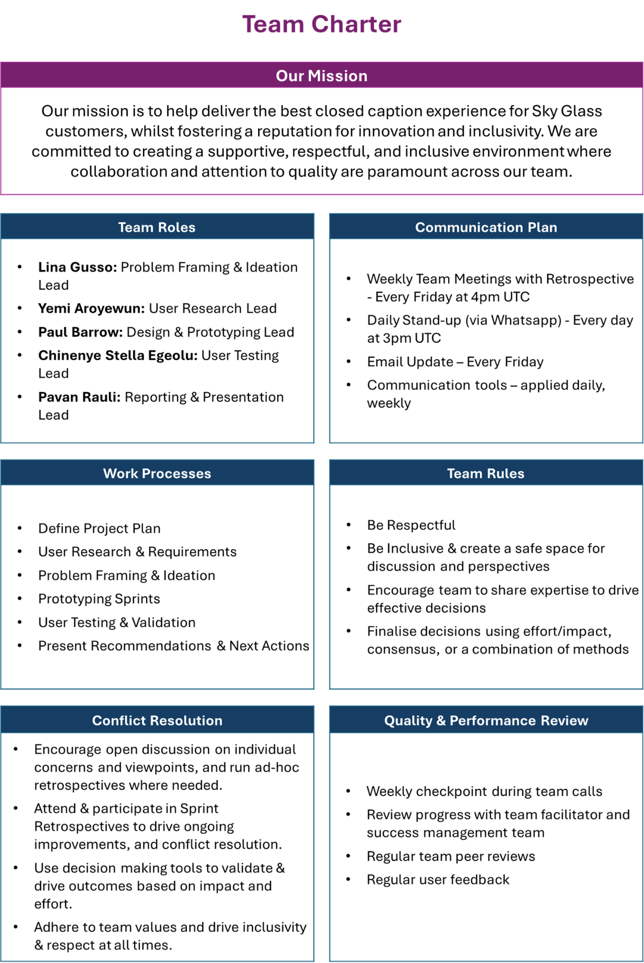

### Collaboration model

In the live sessions to build the Team Charter, the team identified the main activities and where each other's strengths better fit within these. The group has substantial project and programme management experience, in addition to the product management skills learned in the KCL career accelerator course. Some team members' specific competence in accessibility, innovation, and prototyping, combined with a natural preference for testing in others, will help cover all aspects of this project's delivery.

|  |  |  |  |
| --- | --- | --- | --- |
| Phase | Lead Role | | Secondary Role |
| 1. Ideation & Problem Framing |  | Lina Gusso | Pavan Rauli |
| 1. User Research & Experience |  | Yemi Aroyewun | Paul Barrow |
| 1. Design & Prototyping |  | Paul Barrow | Chinenye Stella Egeolu |
| 1. User Testing |  | Chinenye Stella Egeolu | Yemi Aroyewun |
| 1. Reporting & Presentation |  | Pavan Rauli | Lina Gusso |

Since we are a diverse group, we decided each person has a primary lead and secondary role. This will allow for collaborative working to improve the outcomes of the phase or activity and ensure a backup in case of unavailability, as shown in the table above.

## Market Research

As our team considered our approach to this project and formed our plan, we identified alignment between activities and team member’s strengths. Leads and deputies were assigned to activities, and agile reviews established to ensure collaboration and progress.

To understand the problem context more deeply, our team distributed research needed ahead of ideation to focus on two key areas:

* Market Analysis, including CC concepts and recent innovations, analysis of competitors and their accessibility offerings, and potential impact of regulatory changes.
* User Research, to understand the biggest challenges relating to accessibility and CC faced by users today and in the future, background research on TV/streaming accessibility needs.

### TV Market Summary

The UK TV broadcasting market is substantial, with an estimated revenue of £10.6 billion in 2024. Despite a decline in traditional TV viewership, the market remains significant due to the continued demand for live TV and bundled services.

Key Players

The market is dominated by a few major players:

* BBC: As a public service broadcaster, the BBC has a significant share of the market, funded by the TV licence fee.
* ITV: A major commercial broadcaster, ITV generates revenue primarily through advertising.
* Sky: The largest subscription-based provider, Sky offers a wide range of channels and exclusive content.
* Channel 4: Funded by advertising and known for its innovative programming.

Consumer Behaviour

* ‘Cord-Cutting’: There has been a shift from traditional broadcast TV to on-demand and streaming services. However, live TV, particularly for sports and news, remains popular.
* Device Usage: Smart TVs have become the device of choice for many viewers, with a significant increase in household penetration, with additional demand for add-on devices such as Apple TV, Fire Stick and Sky Puck.

Technological Advancements

* Digital Transition: The switch to digital TV has allowed broadcasters to offer more channels and interactive services.
* Streaming Integration: Many broadcasters, such as Sky and BBC, have developed their own streaming platforms to compete with global giants like Netflix and Amazon Prime Video.

Challenges

* Advertising Revenue: The decline in traditional TV viewership has impacted advertising revenue. Broadcasters are adapting by offering targeted advertising and integrating online platforms.
* Regulatory Environment: The freeze on the TV licence fee until April 2024 has financial implications for public service broadcasters like the BBC.

Opportunities

* Content Production: There is a growing demand for high-quality, original content. Investment in local productions and partnerships with international studios can drive growth.
* Regional Expansion: The government encourages investment in regions outside London, which can help diversify and strengthen the industry.

References: IBIS World, 2024, Stoll 2024

### Market Analysis

The UK TV broadcasting market is dynamic and competitive, with an estimated revenue of £10.6 billion in 2024 (IBIS World, 2024). Whilst users continue ‘cord-cutting’, shifting to on-demand and streaming services creating a decline in traditional TV viewership, the market remains significant due to the continued demand for live TV and bundled services.

Sky remains the largest subscription-based broadcaster (Statista, 2024), and by adapting to integrate streaming services, and innovative products such as Sky Glass, compete strongly with the leading global streaming leaders such as Netflix.

Sky’s audience in the UK is diverse, and Ofcom’s research highlighting that 18% of the UK population has a disability, and 10% of all television viewers using subtitles on a daily basis. CC is an essential feature for streaming providers, ensuring accessibility for deaf and hard-of-hearing viewers, as well as those who prefer or need text-based content. To remain truly inclusive and competitive, it is critical Sky continues to grow and innovate in this area.

### Sky TV SWOT

Sky TV is one of the largest digital subscription television companies in the UK and Europe. It holds a significant market share, with a strong presence in the UK, Ireland, Germany, Austria, and Italy.

Strengths

* 1. Strong Brand and Content: Sky offers a wide range of popular channels and exclusive content, including Sky Sports, and Sky Atlantic.
  2. Innovating with Integration: Sky has been at the forefront of technological advancements with products like Sky Q and Sky Glass, which integrate streaming and traditional TV services.
  3. Partnerships: Collaborations with companies like Netflix, HBO and WarnerMedia enhance its content library and customer appeal.

Weaknesses

* 1. Market Saturation: The UK market is highly competitive, with numerous streaming services vying for consumer attention
  2. High Costs: The cost of acquiring premium content and maintaining technological infrastructure is substantial.

Opportunities

* 1. Expansion into New Markets: There is potential for growth in untapped markets and through new product offerings, as outlined during the project brief something Sky are focused on with new products such as Sky Glass.
  2. Digital Transformation: Increasing consumer preference for digital formats and streaming services presents opportunities for Sky to expand its digital footprint.

Threats

* 1. Intense Competition: Sky faces strong competition from other streaming leaders such as Netflix, Amazon Prime Video, and Disney+.
  2. Regulatory Challenges: Changes in regulations and policies could impact Sky’s operations and profitability, particularly in regards to building services and accessibility.

User Base

Sky’s customer base is diverse, with a significant portion of subscribers being families and sports enthusiasts. The introduction of Sky Glass has also attracted tech-savvy consumers looking for integrated TV solutions, often driven by Sky’s investment in infrastructure.

Financial Performance

Sky’s revenue was approximately $19 billion for the fiscal year ending June 2021.

### Closed Caption Research

Closed captioning (CC) is an essential feature for streaming providers, ensuring accessibility for deaf and hard-of-hearing viewers, as well as those who prefer or need text-based content.

The closed captioning services market is growing, driven by increasing demand for accessible content and regulatory requirements. Key players in this market include VITAC, Digital Nirvana, and Rev12.

Strengths

* 1. Regulatory Compliance: Many countries, including the UK and the US, have stringent regulations requiring closed captioning for broadcast and streaming content.
  2. Technological Advancements: Advances in AI and machine learning have improved the accuracy and efficiency of automated closed captioning.
  3. User Demand: **There is a growing demand** for closed captioning from a diverse audience, including non-native speakers, viewers in noisy environments, and those with hearing impairments.

Weaknesses

* 1. Content Coverage often varies between providers, including disparity in language coverage.
  2. Quality Variability: The quality of closed captions can vary significantly between providers, with issues such as timing errors, inaccuracies, and poor synchronization, which is evident in Sky’s own support forums.
  3. Cost: High-quality closed captioning services can be expensive, particularly when relying on other suppliers, which may be a barrier for smaller streaming providers.

Opportunities

* 1. Expansion of Services: There is potential for growth in providing multilingual closed captions and real-time captioning for live events, being driven by new investment in AI & machine learning.
  2. Enhanced User Experience: Improving the accuracy and customization of closed captions can enhance the viewing experience and attract more users.

Threats

* 1. Technological Challenges: Despite advancements, automated closed captioning still faces challenges in accurately capturing complex dialogues, accents, and background noises.
  2. Regulatory Changes: Changes in regulations could impact the requirements and costs associated with closed captioning, something we have found many providers have concerns about when introducing live-captions and AI.

Users

Closed captions are used by a wide range of viewers, including those with hearing impairments, non-native language speakers, and individuals in noisy environments. The demand for closed captions is particularly high among younger audiences, and the “TikTok generation” of multitaskers, who prefer subtitles as they watch TV alongside other activities who consume content on mobile devices.  
  
Our research exposes additional profiles we must consider, showing an increasingly diverse user-base and rapidly evolving trends introduce a broader set of viewer needs. For example, viewers with physical conditions making remote controls including the voice command button obsolete.

References: Advance Market Analytics 2024, Antoniou 2024, Chavez et al 2024, HTF Market Intelligence 2023.

### Competitor Insights & Threats

Sky consistently performs strongly in content coverage and availability. To identify opportunities for improvement and innovation, we researched across the competitive landscape, identifying several opportunities:

* **Netflix:** Offers closed captions in multiple languages (Netflix 2024) and has invested in improving the accuracy and quality of its captions.
* **Amazon Prime Video:** Provides closed captions for most of its content and allows users to customize the appearance of captions (Amazon 2024).
* **Disney+:** Includes closed captions for all its content, with a focus on accuracy and synchronization (Antoniou, 2024).
* **BBC iPlayer**: Known for high-quality closed captions, especially for live broadcasts. (Sandford and Armstrong, 2016)

Whilst Sky continues to have great CC coverage and a simplified experience through Sky Glass, there are key opportunities to exceed competitor offerings available. We assume enabling customization capabilities are being addressed but must go further to gain competitive advantage with users who require enhanced accessibility to improve their viewing experience.

### Comparison of Sky Glass competitors, ranked by CC coverage and CC customisation features

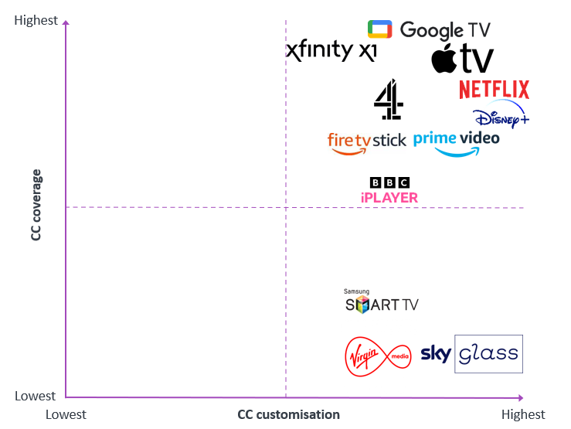

### Closed caption user interface competitor comparison

| **Name** | **Category** | **Markets covered** | **Access to CC** | **Voice Control Access to CC** | **Font Type** | **Font Size** | **Font Style** | **Text Colour** | **Background Colour and Opacity** | **Text Edge Style** | **Caption Position** | **Window Colour and Opacity** | **Language and Translation** | **Speaker Identification** | **Line and Letter Spacing** | **Background Blur** | **Sound Description** | **comments** | **Links** |
| --- | --- | --- | --- | --- | --- | --- | --- | --- | --- | --- | --- | --- | --- | --- | --- | --- | --- | --- | --- |
| SKY GLASS | Smart TV / Streaming Devices | United Kingdom, Ireland, Germany, Austria, Switzerland, Italy. |  | Yes | No | No | No | No | No | No | No | No | Yes | No | No | No | Yes |  | <https://www.youtube.com/watch?v=nfv55ZZnYL0><https://helpforum.sky.com/t5/Sky-Accessibility/Change-the-size-of-subtitles-on-sky-glass/m-p/4463739#M4341> |
| Xfinity X1 by Comcast (Sky is part of ComCast) | Smart TV / Streaming Devices | USA | Large Button Voice Remote  <https://webremote.com/> | Yes | ? | Yes | Yes | Yes | Yes | Yes | No | Yes | Yes | No | No | Yes | Yes |  | <https://www.xfinity.com/support/articles/x1-closed-captioning>  <https://www.xfinity.com/support/articles/xtv-web-setting-accessibility-options> |
| Sky Stream mini Box (Sky Q?) | Smart TV / Streaming Devices | UK | dedicated accessible remote control |  | ? | ? | ? | ? | ? | ? | ? | ? | ? | ? | ? | ? | ? |  | <https://www.youtube.com/watch?v=rtHX23lrJzQ>  <https://www.sky.com/help/articles/using-the-accessibility-settings-on-your-sky-q-box> |
| Sky Go platform | Streaming Service | UK |  |  |  |  |  |  |  |  |  |  |  |  |  |  |  |  | <https://www.sky.com/help/articles/subtitles-on-sky> |
| Amazon Fire Stick | Smart TV / Streaming Devices | Worldwide |  | Yes | ? | Yes | Yes | Yes | Yes | ? | No | ? | Yes | ? | No | ? | Yes |  | <https://www.amazon.com/gp/help/customer/display.html?nodeId=Tb7jgf3OGfR4xiCCYh> |
| Samsung Smart TV | Smart TV / Streaming Devices | Worldwide |  | Yes | No | Yes | No | Yes | Yes | No | No | No | Yes | ? | No | No | ? |  | <https://www.samsung.com/latin_en/support/tv-audio-video/how-to-use-accessibility-features-on-my-samsung-smart-tv/#:~:text=Open%20the%20Closed%20Captions&text=If%20you%20are%20using%20a,be%20seen%20on%20your%20screen.> |
| Virgin Media | Smart TV / Streaming Devices | UK ? |  | Yes | ? | ? | ? | ? | ? | ? | ? | ? | ? | No | ? | ? | ? |  | <https://www.youtube.com/watch?v=azYoRbLw4wg> |
| Apple TV | Smart TV / Streaming Devices | Worldwide |  | Yes | Yes | Yes | No | Yes | Yes | Yes | No | Yes | Yes | ? | No | No | Yes | Google and Apple have presets and then "custom" | <https://www.youtube.com/watch?v=Nql10mXJCUM> |
| Google TV / Chromecast | Smart TV / Streaming Devices | Worldwide |  | Yes | Yes | Yes | Yes | Yes | Yes | Yes | No | ? | Yes | ? | ? | ? | ? | Google and Apple have presets and then "custom" | <https://www.youtube.com/watch?v=z-7kTmEgrrE> |
| Netflix | Streaming Service | Worldwide | present by default when you launch content | n/a | No | Yes | Yes | ? | No | No | No | No | Yes | Yes | ? | ? | ? |  | <https://help.netflix.com/en/node/100267> |
| Disney+ | Streaming Service | Worldwide |  | n/a | Yes | Yes | Yes | Yes | Yes | Yes | No | ? | Yes | Yes | ? | ? | ? |  | <https://www.youtube.com/watch?v=nJPZGnuEGNY> |
| Prime Video | Streaming Service | Worldwide |  | n/a | No | Yes | No | Yes | No | No | No | No | Yes | Yes | No | No | Yes |  |  |
| Paramount+ | Streaming Service | Worldwide |  | n/a |  |  |  |  |  |  |  |  |  | Yes |  |  |  |  |  |
| BBC iPlayer | Streaming Service | UK |  | n/a | No | Yes | No | No | No | No | No | No | ? | No | No | No | ? |  |  |
| Channel 4 | Streaming Service | UK |  | n/a | ? | ? | ? | ? | ? | ? | ? | ? | ? | No | ? | ? | ? |  |  |
| Hulu | Streaming Service | USA |  | n/a | Yes | Yes | ? | Yes | Yes | Yes | No | Yes | Yes | ? | No | ? | ? |  |  |
| Roku | Streaming Service | Worldwide |  | n/a | Yes | Yes | ? | Yes | Yes | Yes | No | Yes | Yes | ? | No | ? | ? | ROKU has Select Captions mode: On always On replay On mute Off |  |

### Competitors caption menus

|  |
| --- |
| Apple TV caption menu (Hollington 2021)   1. Apple TV: Accessibility options |
|  |
| 1. Apple TV: Caption size options    |
| 1. Apple TV: Caption style setup options    |

|  |
| --- |
| Amazon Prime closed caption menu (Arch 2020)  1) Amazon Prime: Subtitle setting menu |
|  |
| 2) Amazon Prime: Subtitle format menu   |

|  |
| --- |
| BBC iPlayer closed caption menus (BBC 2024)  1) Closed caption formatting menu – from video |
|  |
| 2) Closed caption formatting – setting menu   |

|  |
| --- |
| Disney+ closed caption menu (Stephenson 2022) |
|  |
|  |

|  |
| --- |
| Hulu closed captions menu (Hulu 2024) |
|  |

|  |
| --- |
| Netflix closed captions menu (Lei 2022) |
|  |

|  |
| --- |
| Roku closed captions style menu (Roku 2024) |
|  |
| Sky closed caption menus (Sky.com 2024)  1) Accessibility menu |
|  |
| 2) Accessibility menu (alternative) |

### Sky Glass CC SWOT Analysis

See Appendix 7.2.5: ‘Competitor Threats & Insights’ above for more details.

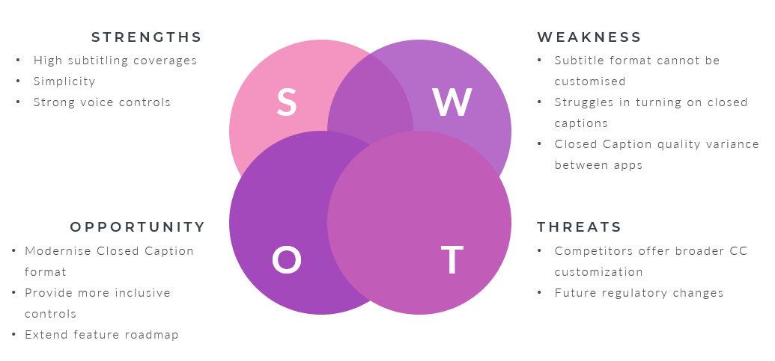

### Porters Five Forces Analysis

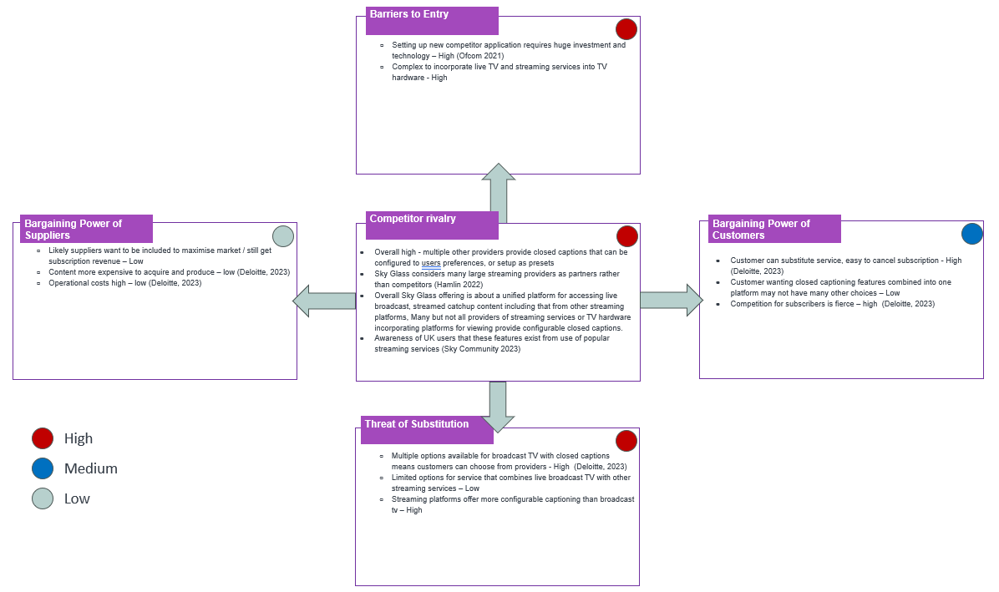

## User Research

### User Analysis

Most commonly known users of CC services are users with hearing and visual impairments, closely followed by language learners and those with cognitive challenges who understand content more deeply through reading.

Our research exposes additional profiles we must consider, showing an increasingly diverse user-base and rapidly evolving trends introduce a broader set of viewer needs. For example, viewers with physical conditions making remote controls including the voice command button obsolete, and the “TikTok generation” of multitaskers, who prefer subtitles as they watch TV alongside other activities.

We have identified core themes spanning the broader audience - users want the ability to customize their experience, and increasingly accessible ways to interact with Sky’s services.

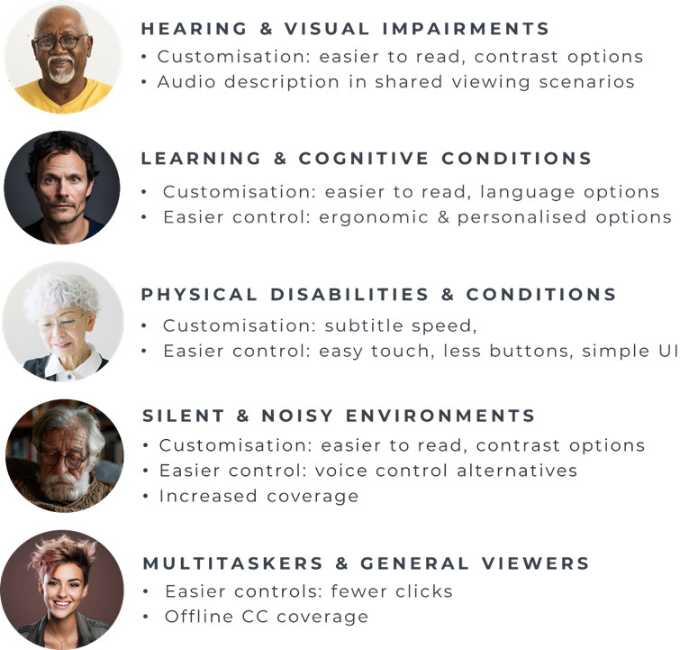

### Persona Empathy Map

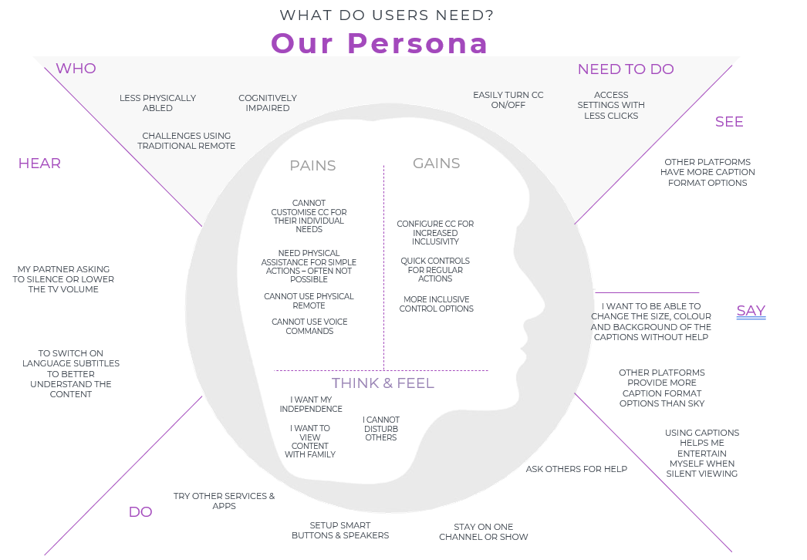

Reference: mural.co, n.d.

### Sky Communities

* Subtitle Customisation Asks:

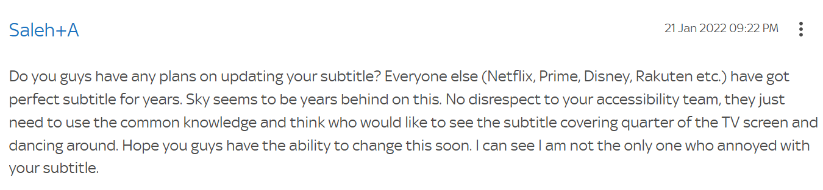

[Subtitle customisation | Sky Community](https://helpforum.sky.com/t5/Sky-Accessibility/Subtitle-customisation/td-p/3902442)

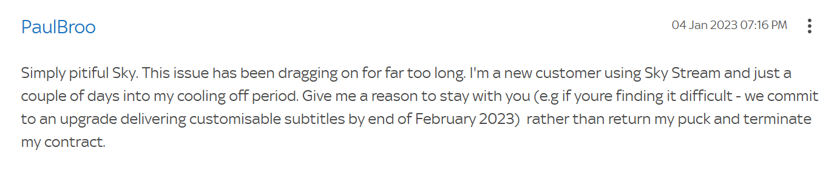

[Answered: Re: Sky stream subtitles are very big and intrusiv... - Page 6 | Sky Community](https://helpforum.sky.com/t5/Sky-Accessibility/Subtitles-are-far-too-large-and-intrusive-Friends-and-family-are-furious-that-subtitles-can-t-be-s/m-p/4281014)

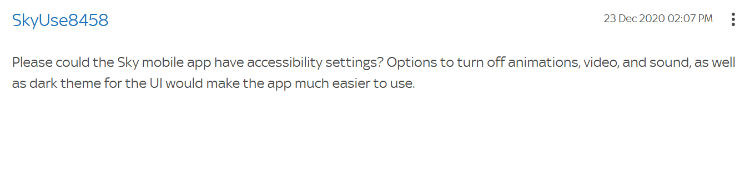

[Sky app accessibility settings | Sky Community](https://helpforum.sky.com/t5/Sky-Accessibility/Sky-app-accessibility-settings/td-p/3552780)

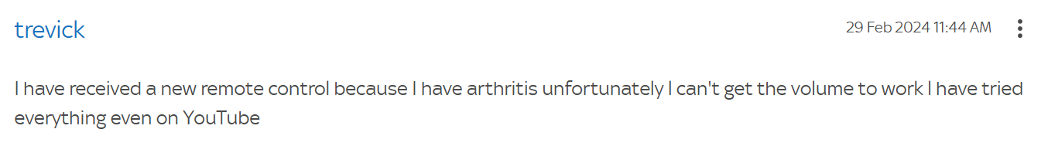

[Remote control for people with disabilities | Sky Community](https://helpforum.sky.com/t5/Sky-Accessibility/Remote-control-for-people-with-disabilities/td-p/4576314)

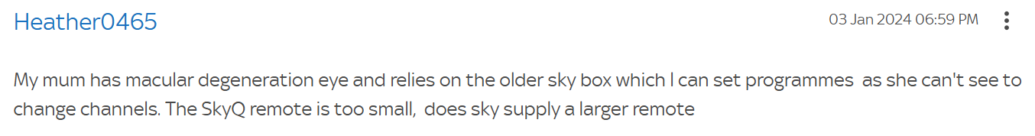

[Answered: Visually impaired remote control | Sky Community](https://helpforum.sky.com/t5/Sky-Accessibility/Visually-impaired-remote-control/td-p/4526329)

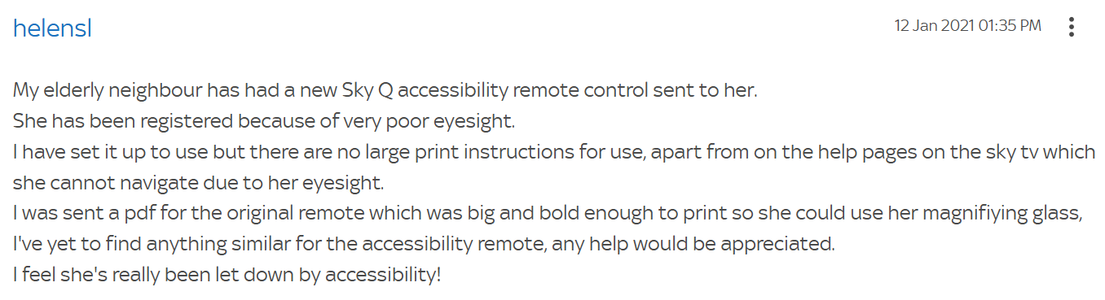

[Sky Q accessibility control | Sky Community](https://helpforum.sky.com/t5/Sky-Accessibility/Sky-Q-accessibility-control/td-p/3573664)

## Ideation

### Problem Research & Ideation

Research shows that 80% of disabled users have experienced accessibility issues with streaming services with 1 in 5 users cancelling their subscription as a result (Scope, 2020).

To compete with the broader market, and meet the demand of the Sky audience, introducing closed caption customisation is a critical next step, which we understand Sky Glass are investigating. The next common need was to access these, and other accessibility features, with the utmost ease – fewer clicks, alternatives to physical remotes, and simpler ways for these users to get support for true inclusivity. Our team focused opportunities to enhance Sky Glass inclusivity, starting with accessible control of closed caption configuration during ideation.

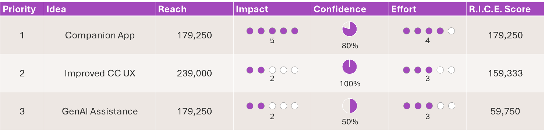

**Ideation prioritisation - Value and Effort**



### Mind mapping

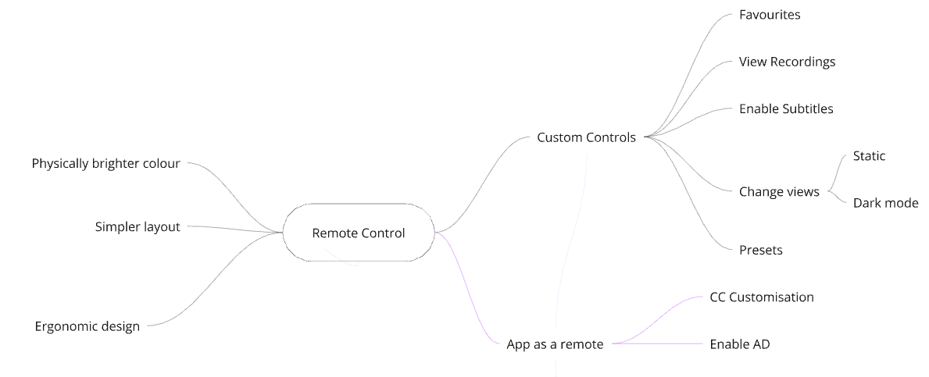

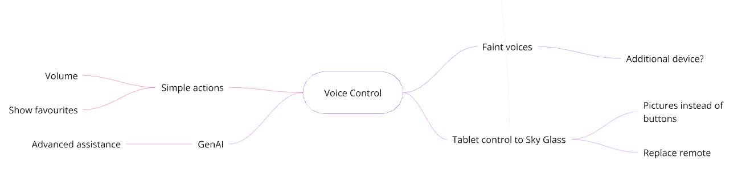

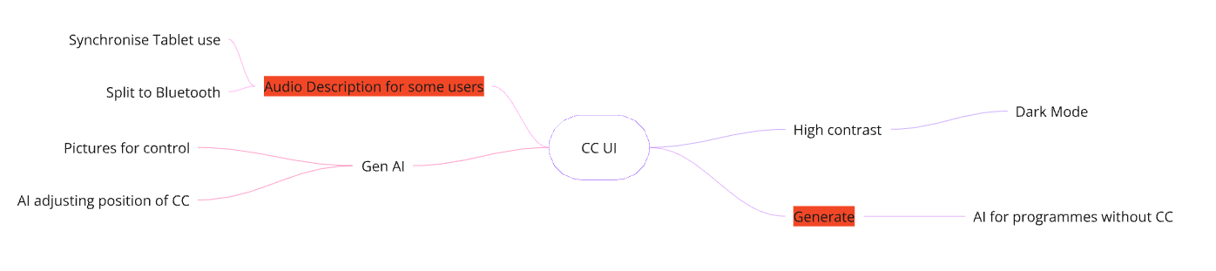

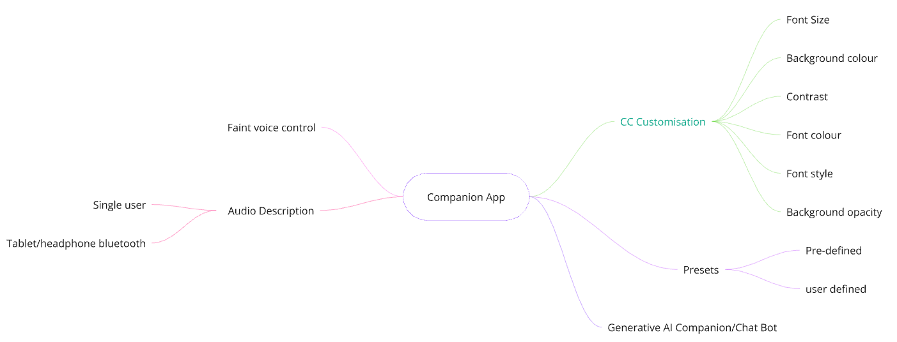

### Blue Sky thinking

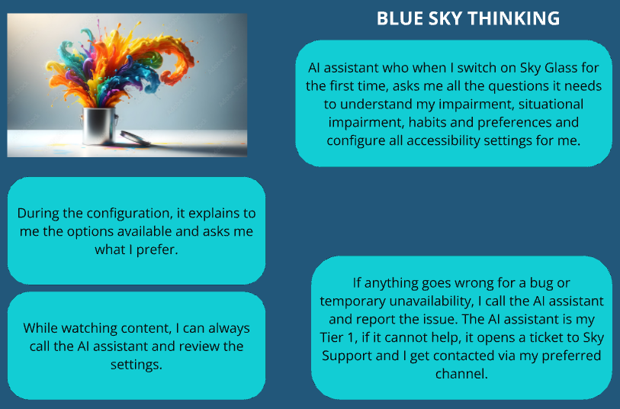

### Opportunity Solutions Tree

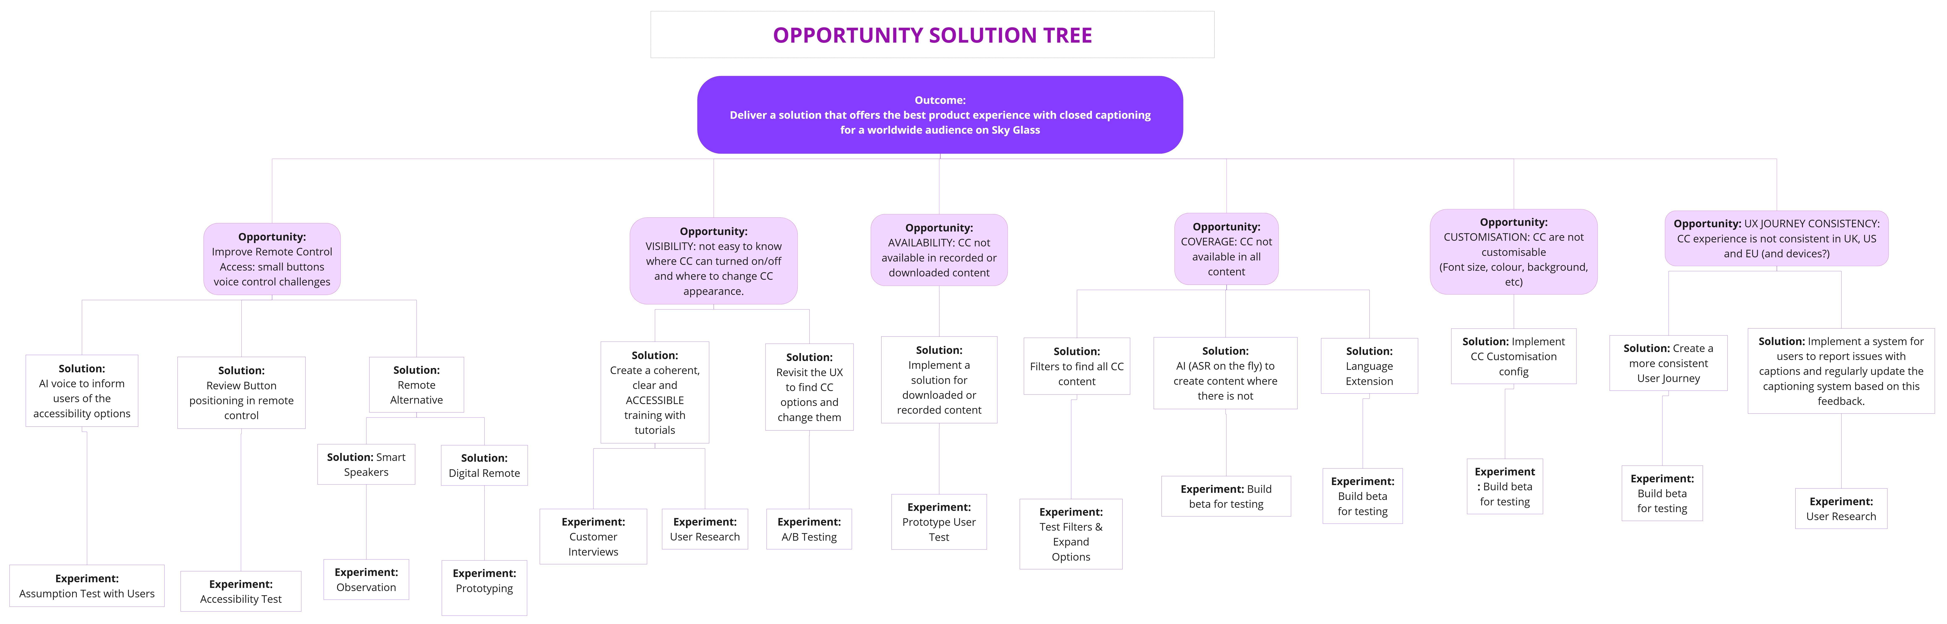

### Riskiest assumption canvas

Yellow highlighted scores show assumptions identified as riskiest by individual.

| **Assumption Type** | **Assumption** | **Lina** | | | **Pav** | | | **Paul** | | | **Stella** | | | **Yemi** | | |
| --- | --- | --- | --- | --- | --- | --- | --- | --- | --- | --- | --- | --- | --- | --- | --- | --- |
| **Impact on product outcome:** | **Uncertainty of being right/wrong** | **Total risk level:** | **Impact on product outcome:** | **Uncertainty of being right/wrong** | **Total risk level:** | **Impact on product outcome:** | **Uncertainty of being right/wrong** | **Total risk level:** | **Impact on product outcome:** | **Uncertainty of being right/wrong** | **Total risk level:** | **Impact on product outcome:** | **Uncertainty of being right/wrong** | **Total risk level:** |
| USERS | We believe current users of Closed Captions are primarily those with hearing impairments, and that there is a growing set of users across new scenarios such as those with physical impairments, cognitive and learning challenges, silent viewers, and multitaskers. | 5 | 1 | **5** | 5 | 1 | **5** | 5 | 1 | **5** | 5 | 1 | **5** | 5 | 1 | **5** |
| USERS | We believe that Closed Caption users want the ability to a customise subtitling format by size, colour, and style. | 5 | 3 | **15** | 5 | 3 | **15** |  |  | **0** | 5 | 3 | **15** | 5 | 4 | **20** |
| USERS | We believe that Closed Caption users want more accessible ways to access and customise their experience, enabling scenarios such as silent and independent viewing, and supporting those who cannot use existing controls. | 5 | 3 | **15** |  |  | **0** |  |  | **0** |  |  | **0** | 5 | 2 | **10** |
| PROBLEM | We believe that users will benefit from and utilise extensive customisation options for font size, style, colour and background | 5 | 1 | **5** | 5 | 1 | **5** | 5 | 1 | **5** | 4 | 3 | **12** | 5 | 2 | **10** |
| PROBLEM | We believe that accessibility users would use closed captions | 5 | 1 | **5** | 5 | 1 | **5** | 5 | 1 | **5** | 5 | 2 | **10** | 5 | 1 | **5** |
| SOLUTION | We believe that users would find it easy and intuitive to use closed captions | 5 | 3 | **15** | 5 | 3 | **15** | 4 | 4 | **16** | 4 | 1 | **4** | 4 | 2 | **8** |
| PROBLEM | We believe some users need simple alternatives to existing voice commands in certain scenarios, such as silent viewing, fainter voices, and where users cannot physically use the remote. | 5 | 4 | **20** | 5 | 5 | **25** | 4 | 4 | **16** | 4 | 4 | **16** | 4 | 3 | **12** |
| SOLUTION | We believe users will use a secondary device (tablet or mobile) to engage for more accessible use of Sky Glass. | 5 | 7 | **35** | 5 | 6 | **30** | 5 | 7 | **35** | 4 | 7 | **28** | 5 | 5 | **25** |
| SOLUTION | We believe that accessibility users will benefit from a dedicated Companion App for centralised and consistent configuration of their preferences and easy access to a wider range of accessibility support | 5 | 8 | **40** | 5 | 4 | **20** | 5 | 5 | **25** | 5 | 4 | **20** | 5 | 6 | **30** |
| SOLUTION | We believe it is technically feasible to build a companion tablet/mobile app with connectivity and response performance that delivers a great user experience. | 5 | 5 | **25** | 5 | 4 | **20** | 5 | 5 | **25** | 4 | 6 | **24** | 5 | 6 | **30** |
| SOLUTION | We believe that closed captioning can support multiple languages across a majority of content. | 5 | 5 | **25** | 5 | 6 | **30** | 3 | 5 | **15** | 5 | 7 | **35** | 4 | 6 | **24** |
| SOLUTION | We believe that a modern closed caption format, replacing teletext, will display all the words accurately according to the audio dialogue | 5 | 6 | **30** | 5 | 4 | **20** | 4 | 3 | **12** | 3 | 5 | **15** | 3 | 6 | **18** |
| COMPETITION | Closed Caption customisation on Sky services will help improve customer experience and prevent users moving to alternatives due to inclusivity or accessibility needs. | 5 | 3 | **15** | 3 | 4 | **12** | 5 | 4 | **20** | 5 | 3 | **15** | 3 | 6 | **18** |
| COMPETITION | The Sky Companion App will provide a competitive advantage for Sky Glass and other Sky services, incorporating inclusivity and accessibility enhancements, and supporting the longer term ability to quickly respond to regulatory requirements. | 5 | 3 | **15** | 5 | 3 | **15** | 4 | 4 | **16** | 5 | 3 | **15** | 4 | 4 | **16** |

## Prototype

### Version 1 Caption Configuration Prototype (see Section 4 for the final prototype)

|  |
| --- |
| **Step 1 – Version 1 prototype main captions menu:** Prototype Sky Glass captions menu displayed on a TV |
| **Step 2 - Version 1 prototype caption text size menu:** Userchoices for caption font and size |
| **Step 3 - Version 1 prototype caption text size menu:** Userchoices for caption colour and background |

### Version 1 prototype Companion App – with presets (see Section 4 for final Prototype)

|  |
| --- |
| **Step 1 - Version 1 prototype Companion App:** home screen   |
| **Step 2 - Version 1 prototype Companion App:** setup caption format screen   |

### Version 2 prototype Companion App – with presets (see Section 4 for final prototype)

|  |
| --- |
| **Prototype Companion App 2:** Home screen including caption presets   |

## User Testing

### User Test Plan

Test plan based on the hypothesis and riskiest assumption:

1. **Overall Hypothesis**

The core hypothesis is that by enabling users to customise closed captions and providing them with easy-to-access configuration controls using a companion app, Sky Glass can increase inclusivity, accessibility, and user satisfaction.

1. **Riskiest Assumption**

The riskiest assumption is that users will utilise a secondary device (tablet or mobile) to interact with Sky Glass for a more accessible experience.

**Test Objectives**

There are two Test Objectives, one to validate a usability assumption and the other to validate the desirability assumption:

1. Using the Companion App to enable and customise Closed Captions (Usability)
   1. Users will switch on TV from the Companion App and enable Closed Captions
   2. They will use the presets offered
   3. They will customise further by selecting either one of the three offered options (Font Size, Colour, Background)
2. Perception of the Companion App (Desirability)
   1. Validate the use of a companion app for improved accessibility and customisation.
   2. Assess the ease of use and intuitiveness of the companion app's interface and controls.
   3. Measure the impact of the companion app on user satisfaction and overall experience.
   4. Identify any potential usability issues or challenges with the companion app.
   5. Users will download the Companion App on either their tablet or mobile.

**Test Methodology**

* **Usability Testing:** Conduct usability testing sessions with a diverse group of users, including those with accessibility needs, to observe their interactions with the companion app and gather feedback on its effectiveness.
* **Survey and Feedback:** Collect user feedback through surveys and questionnaires to gauge their overall satisfaction with the companion app and identify areas for improvement.

**Test Participants**

Whilst our focus is to test the solution with users who require a more accessible and easier to use method of enabling and customising their closed caption experience than traditional remote controls, our initial testing will include a range of users to gather fast feedback, including both those with physical conditions, those who prefer using a digital alternative, and general viewers who use closed captions.

In summary, we will test:

* **Individuals with accessibility needs:** Recruit participants with varying levels of visual, hearing, motor challenges to ensure the companion app caters to a wide range of needs, and enhances accessibility.
* **Individuals without accessibility needs:** Recruit participants with no reported accessibility needs who use closed caption and test their willingness to adopt and utilise the companion app for enhanced customisation experience  and inclusive viewing.

In future testing, our recommendation will be to go deeper with specific users who have physical barriers to using the existing methods of configuring Sky Glass.

**Test Scenarios**

* **Scenario 1:** use of a mobile app to enable and customise Closed Caption on the TV:
  1. Switch on TV & Enable Closed Captions
  2. Use one of the presets
  3. Customise:
     + - Change Font Size or
       - Change Colour Style or
       - Change Background
* **Scenario 2:** Overall understanding and desirability of the concept of companion app

**Success Metrics**

* **Task success rate (%):** Measure the percentage of participants who successfully complete each task related to closed caption customisation and accessibility settings using the companion app. [Met/Partially Met/Not Met]
* **Task completed in a reasonable time (Yes/no):** Track the time it takes participants to complete tasks using the companion app within expected durations **(<3 seconds, <5 seconds or >5 seconds)**
* **Error rate (%):** Monitor the number of errors or difficulties participants encounter while using the companion app.
* **User satisfaction:** Collect feedback on user satisfaction with the Companion App through surveys and questionnaires.

### Test Script

**Demographics**

|  |  |
| --- | --- |
| Age range |  |
| Gender |  |
| Accessibility needs |  |
| TV devices used |  |
| Assistive technology used |  |
| Smart technology used (app, tablet etc) |  |
| Employment status |  |
| Location type (urban, etc) |  |
| Geographic location / Country |  |

**Warm up questions**

| Could you tell me about your current use of closed captions/subtitles when watching live TV or films? |  |
| --- | --- |
| Please tell me about the last time you used closed captions when viewing TV? |  |

**Introduction**

"Hello *[Tester 1]*, thank you for participating in our usability testing session today. Your feedback is invaluable in helping us improve the user experience of our streaming service. Before we begin, I'd like to ask for your consent to record this session for analysis purposes and use the notes and observations that we will jot down during the session. Do we have your permission to record?"

*[record participant's consent and start recording]*

"Great, thank you. Before starting I would also like to highlight that there are no right or wrong answers, and we're testing the product feature you’ll see in a moment, not you. We are about to show you a high-level flow and screens and give you a few tasks to do and questions to answer. It would be helpful if you can describe your thinking out loud as you navigate through the tasks. Are you ready to get started?"

**Scenario 1: Enable and Customise Closed Caption on your TV by using a companion app. Task participants using the companion app.**

[Tablet prototype](https://www.figma.com/proto/chCZCfVNuZyPipWSnSTRAR/Caption-menu?node-id=230-6794&t=MvMNxyYzzBbIuQdt-0&scaling=scale-down&content-scaling=fixed&page-id=0%3A1&starting-point-node-id=229%3A1053)

* We have created a companion app for this TV service in an effort to enhance accessibility of these settings
* Please take a moment to familiarise yourself with the screen you have landed on
  + [ACTION 1] Using this application, switch on the TV and enable closed captions. How easy or difficult did you find that?
  + [ACTION 2] Please configure the closed captions to white text with a black background
  + [ACTION 3] Change Font Size: You now see the closed captions displayed.  What do you think of the current size of the closed captions? Where do you go to change the size? Walk me through the steps you took to complete this task.
  + [ACTION 4] Change Colour Style. Where do you go to change the style? Walk me through the steps you took to complete this task.
* How would you rate the ease of completing these tasks: on a scale of 1 to 5, with 1 being very difficult and 5 being very easy, how would you rate this?
* Are there any other options you would expect or like to see?

**Scenario 2: Understanding feedback on the companion apps concept**

* Do you use any mobile or tablet apps alongside using streaming services on your TV? For example, Apple TV iPhone companion for typing, Virgin Media remote app to control your set-top-box  etc
* If yes, what would you like these companion apps to do? What do you like and/or dislike about these apps? Which features do you wish these apps provided that they do not already?
* If no, what is the reason you do not use these apps? Awareness, device availability, app exhaustion, add more.
* Could such apps make your viewing experience more accessible?
* Would you go back to the remote?
* **Added**: our intention with the feature was to look at ways of enabling closed caption use for users who cannot use a traditional remote due to physical challenges, or complexity through the configuration menus - if a remote was not an option, could this app provide a suitable alternative?

**Follow-up questions & Conclusion**

"Great job! You've completed all the tasks. Before we conclude, do you have any additional comments or feedback on the usability of these screens? Your insights have been precious to us.”

"Thank you so much for your participation today. Your feedback will help us improve the user experience for all our users. If you have any further questions or thoughts, please feel free to share them with us. Have a great day!"

### Success Criteria

**Scenario 1:** use of a mobile app to enable and customise Closed Caption on the TV

ACTION 1 - Switch on TV and Closed Captions

* Success Criteria: The participant successfully switch the TV on and enable CC
* Measured by: Participant navigates easily and does not look confused. He performs the tasks in > 5 secs.

ACTION 2 - use preset white text / black background

* Success Criteria: The participant successfully selects the preset with white text and a black background as instructed
* Measured by: Participant navigates to the “Subtitles Style” and makes the selection effortlessly and within 10 secs. They rate the ease of the experience 4 or 5 out of 5.

ACTION 3 - Change Font Size

* Success Criteria: The participant successfully access the “Customise Subtitles” and changes font size.
* Measured by: Participant successfully navigates to the font size options and select the preferred one and completes the task within 10 secs. They rate the ease of the experience 4 or 5 out of 5.

ACTION 4 - Change Colour Style

* Success Criteria: The participant successfully accesses the “Customise Subtitles” and changes font size.
* Measured by: Participant successfully navigates to the font size options and selects the preferred one and completes the task within 10 secs. They rate the ease of the experience 4 or 5 out of 5.

**Scenario 2:**  Overall understanding and desirability of the concept of companion app

Questions on overall usability and desirability

* Success Criteria: The participant provides feedback and rating

Measured by: 1-5 scale

### Methodology of Testing

* **Participants:** Testing involved 10 Participants, including individuals with mobility impairments, hearing difficulties, central vision issues, and multitaskers/silent viewers.
* **Test Environment:** Participants interacted with the Companion App in a controlled environment, where they were asked to complete a series of tasks using devices such as Laptops and tablets.
* **Tasks:** We asked participants to perform some test tasks which included turning on TV on/off, enabling/disabling subtitles, customising subtitle styles and navigating through different app functions.
* **Data Collections:** Data was collected through direct observation, user feedback, recording and task completion metrics.

### User Testing Results

([AirTable Link](https://airtable.com/appn0z4nVrHaV2tXL/shrNRjskw2aWlBzqX))

**Tester demographics and characteristics**

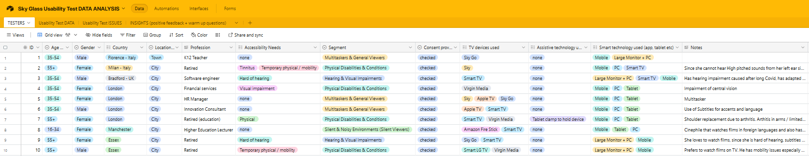

**Test results grouped by tester (sample)**

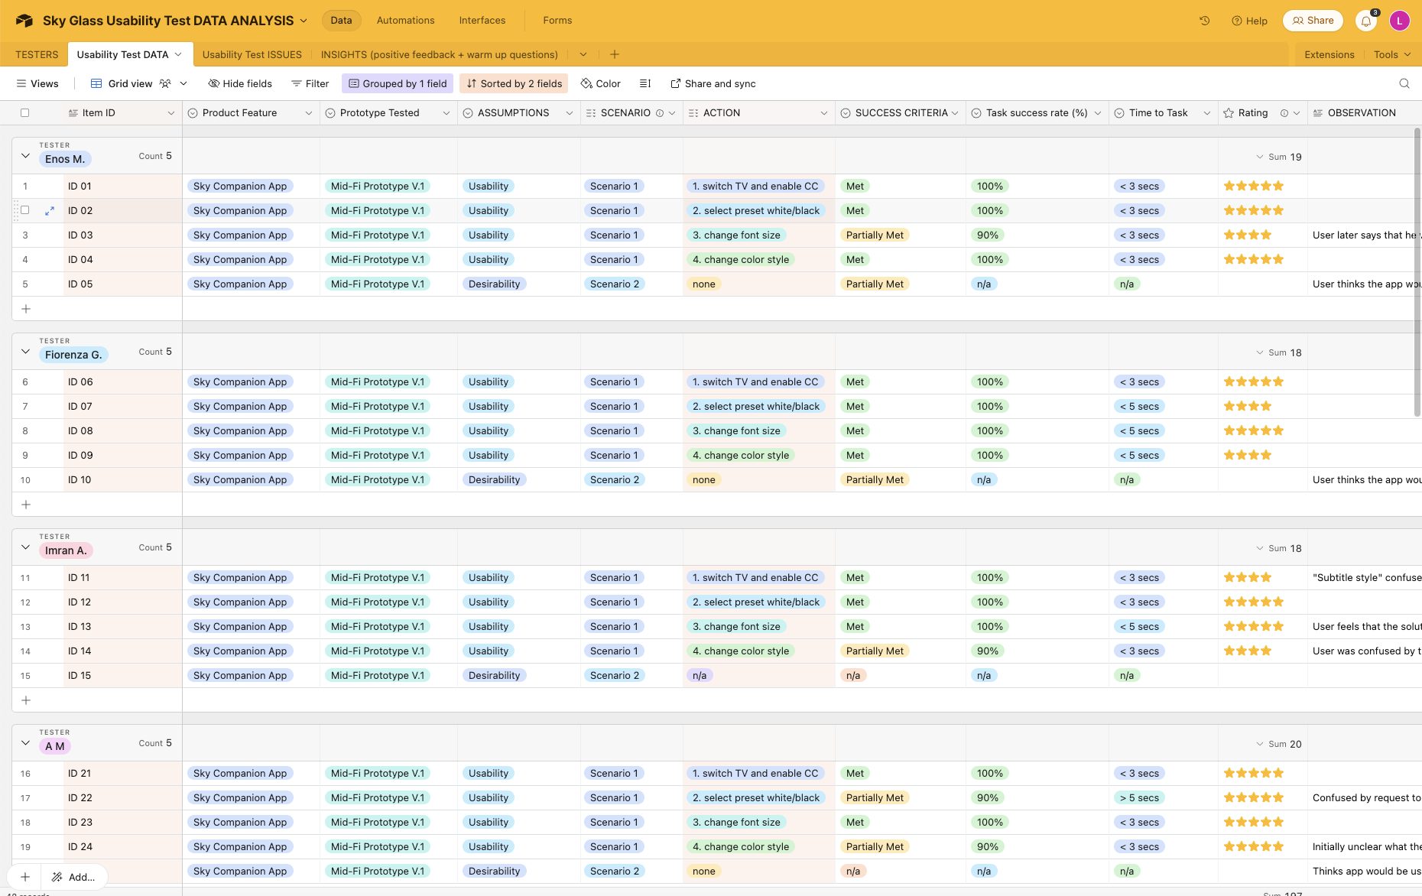

**Test results (ungrouped)**

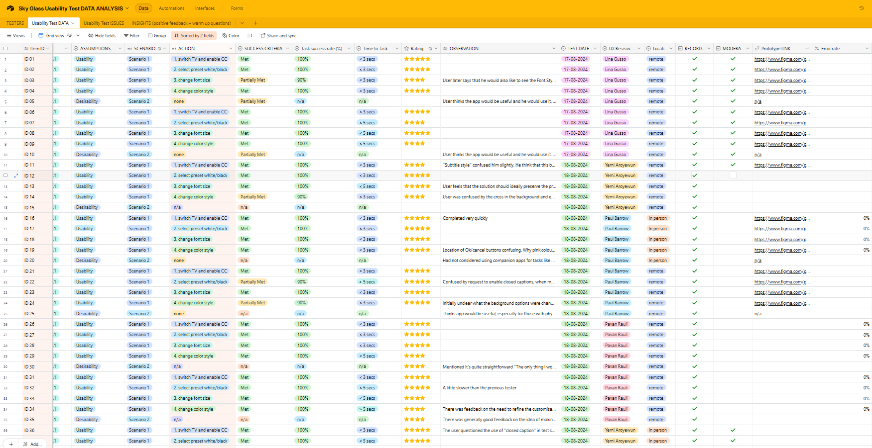

**Test issues recorded during actions**

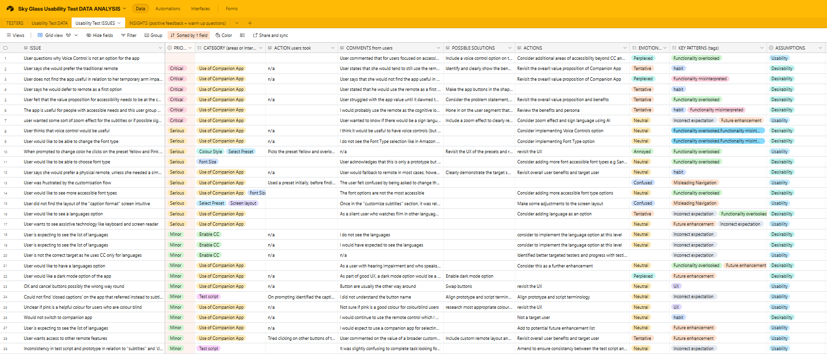

**Tester insights and feedback**

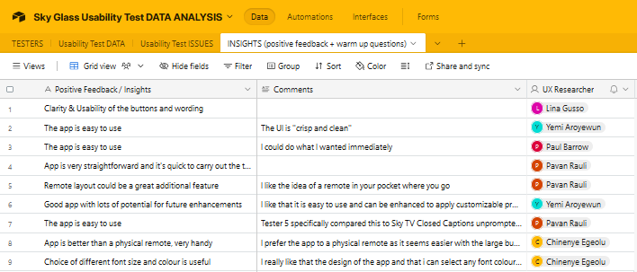

### Results - graphs

# References

Advance Market Analytics. (2024). *Closed Captioning Services Study by Type (Standard, Premium), Platform (TV Media, Non TV Media), Caption (Off-line, Pop-on, Roll-up, Online, Live-Display, Others) Players and Region - North America Market Outlook to 2027*. [online] Available at: https://www.advancemarketanalytics.com/reports/112795-global-closed-captioning-services-market [Accessed 1 Aug. 2024].

Amazon Fire TV (2022). *‘Alexa, play something on netflix.’* [online] Medium. Available at: <https://amazonfiretv.blog/alexa-play-something-on-netflix-e8d8f4fe5115> [Accessed 28 Jul. 2024].

amazon.co.uk. (2024). *Turn on subtitles or captions on prime video on connected devices - amazon customer service*. [online] Available at: <https://www.amazon.co.uk/gp/help/customer/display.html?nodeId=GYSDCV5YBV4UWQ56> [Accessed Aug. 2024].

amberscript.com. (2023). *Closed Captioning: Everything you need to know | Amberscript*. [online] Available at: <https://www.amberscript.com/en/blog/closed-captioning-guideline/#benefits-and-impact-of-closed-captioning> [Accessed 20 Aug. 2024].

Andrea (2023). *Measuring User Engagement Experiences to Drive Product-Led Growth*. [online] userpilot.com. Available at: <https://userpilot.com/blog/measuring-user-engagement-for-plg/> [Accessed 29 Jul. 2024].

Antoniou, J. (2024). *The future for streaming services and closed captioning -*. [online] Capital Captions. Available at: <https://www.capitalcaptions.com/subtitles-and-captioning/the-future-for-streaming-services-and-closed-captioning/> [Accessed Jul. 2024].

Apple (2024). *Download apps on your apple TV – apple support (UK)*. [online] Apple Support. Available at: <https://support.apple.com/en-gb/102348> [Accessed Aug. 2024].

Arch (2019). *How to turn closed captioning on or off on amazon prime video*. [online] Tech Junkie. Available at: <https://www.techjunkie.com/closed-captioning-on-off-amazon-prime-video/> [Accessed Aug. 2024].

Audience expectations of access services across TV and Video-on-Demand services Report. (2024). Available at: <https://www.ofcom.org.uk/siteassets/resources/documents/research-and-data/accessibility-research/audience-expectations-of-access-services-across-tv-and-video-on-demand-services/audience-expectations-of-access-services-across-tv-and-video-on-demand-services-report.pdf?v=367355>. [Accessed Jul. 2024].

Ballard, J. (11AD). *Most American adults under 30 prefer watching TV with subtitles — even when they know the language | YouGov*. [online] today.yougov.com. Available at: <https://today.yougov.com/entertainment/articles/45987-american-adults-under-30-watching-tv-subtitles> [Accessed 26 Jul. 2024].

bbc.co.uk. (2024). *How do I use subtitles on BBC iPlayer? | iPlayer help*. [online] Available at: <https://www.bbc.co.uk/iplayer/help/questions/accessibility/using-subtitles> [Accessed 5 Aug. 2024].

Bland, J. (2023). *Moderated Usability Testing 101*. [online] Articles on everything UX: Research, Testing & Design. Available at: <https://blog.uxtweak.com/moderated-usability-testing/#:~:text=Moderated%20usability%20tests%20are%20straight%2Dforward%20to%20set%20up&text=It%20is%20possible%20to%20test> [Accessed 26 Aug. 2024].

Bright, K. (2022). *Team charter*. [online] www.ppd.admin.cam.ac.uk. Available at: <https://www.ppd.admin.cam.ac.uk/leadership-development/team-charter> [Accessed Jul. 2024].

bt.com. (2024). *Turning on subtitles on your EE TV box*. [online] Available at: <https://www.bt.com/help/tv/turning-on-subtitles-on-your-bt-tv-box> [Accessed Aug. 2024].

CaptioningStar (2023). *How YouTube contributed to the evolution of closed captions*. [online] CaptioningStar. Available at: <https://www.captioningstar.com/youtubes-contribution-to-the-evolution-of-closed-captions/> [Accessed Jul. 2024].

channel4.com. (2024). *Subtitled, audio described and signed programming | channel 4*. [online] Available at: <https://www.channel4.com/4viewers/accessibility/subtitled-audio-described-and-signed-programming>. [Accessed 27 Jul. 2024].

Chavez, M.A., Feanny, M., Seita, M., Thompson, B., Delk, K., Officer, S., Glasser, A., Kushalnagar, R. and Vogler, C. (2024). ACM Digital Library: How Users Experience Closed Captions on Live Television: Quality Metrics Remain a Challenge. arXiv (Cornell University). [online] doi:https://doi.org/10.1145/3613904.3641988.

Consumer and Governmental Affairs (2011). *Closed captioning on television*. [online] Federal Communications Commission. Available at: <https://www.fcc.gov/consumers/guides/closed-captioning-television> [Accessed Aug. 2024].

contentfries.com. (2023). *8 essential subtitle customization techniques to boost your video engagement*. [online] Available at: <https://www.contentfries.com/blog/8-essential-subtitle-customization-techniques-to-boost-your-video-engagement> [Accessed Jul. 2024].

Corpuz, J. (2020). *Best Android remote control apps*. [online] Tom’s Guide. Available at: <https://www.tomsguide.com/round-up/best-android-remote-apps> [Accessed 25 Aug. 2024].

Cremona, P. (2022). *The UK’s best streaming services compared: Netflix vs amazon prime vs disney plus vs NOW vs apple TV+*. [online] Radio Times. Available at: <https://www.radiotimes.com/tv/what-to-watch-tv/best-streaming-service-uk/> [Accessed 28 Jul. 2024].

Crowther, A. (2022). *Creating accessibility personas*. [online] Medium. Available at: <https://uxdesign.cc/creating-accessibility-personas-e7749d4096b4>. [Accessed Jul. 2024].

Davies, H. (2019). *Lights, camera, caption! Why subtitles are no longer just for the hard of hearing*. [online] the Guardian. Available at: <https://www.theguardian.com/tv-and-radio/2019/jul/21/subtitles-tv-hearing-no-context-twitter-captions> [Accessed 1 Aug. 2024].

disneyplus.com. (n.d.). *https://help.disneyplus.com/en-GB/article/disneyplus-en-uk-format-captions*. [online] Available at: <https://help.disneyplus.com/en-GB/article/disneyplus-en-uk-format-captions> [Accessed Aug. 2024].

Downey, C. (2022). *How closed captions benefit more than the deaf and hard of hearing*. [online] Rev. Available at: <https://www.rev.com/blog/caption-blog/how-captions-benefit-more-than-the-deaf-and-hard-of-hearing> [Accessed Aug. 2024].

EC (2012). *Waste from Electrical and Electronic Equipment (WEEE)*. [online] environment.ec.europa.eu. Available at: <https://environment.ec.europa.eu/topics/waste-and-recycling/waste-electrical-and-electronic-equipment-weee_en>. [Accessed 7 Aug. 2024].

Elder, S. (2024). *‘Employer project live session 1 Q&A with sky’ [Presentation], kings college london career accelerator in product managment.* [online] zoom.us. Available at: <https://us06web.zoom.us/rec/share/nGgiAZitcYmTkA7lvW41DWdDWuU3KP_p2PVZ3EnU1BEulgTnvcI8XhN0ZcYuY6P-.CM6zUaYH9AbiGiLZ> [Accessed Jul. 2024].

Federal Communications Commission. (2011). *Closed captioning on television*. [online] Available at: <https://www.fcc.gov/consumers/guides/closed-captioning-television> [Accessed Jul. 2024].

Federal Communications Commission. (2014). *Closed Captioning of Video Programming FCC 14-12*. [online] Available at: <https://docs.fcc.gov/public/attachments/FCC-14-12A1.pdf> [Accessed Jul. 2024].

Geekster (2023). *The Impact of Streaming Services on Traditional Television and the Future of Broadcasting*. [online] theretronetwork.com. Available at: <https://theretronetwork.com/the-impact-of-streaming-services-on-traditional-television/> [Accessed 19 Aug. 2024].

Goren, O. (2024). *Sky adds 4K subtitles as customers threaten to cancel*. [online] Cord Busters. Available at: <https://www.cordbusters.co.uk/sky-adds-limited-4k-subtitles/> [Accessed Jul. 2024].

grandviewresearch.com. (2024). *Pay TV market size, share, trend | industry report 2020-2027*. [online] Available at: <https://www.grandviewresearch.com/industry-analysis/pay-television-tv-market> [Accessed 29 Jul. 2024].

Grummitt, C. (2014). *Subtitles Viewer!* [online] Apple App Store. Available at: <https://apps.apple.com/gb/app/subtitles-viewer/id877811411?see-all=reviews> [Accessed 25 Aug. 2024].

Hamlin, J. (2022). *How Sky Glass and Amazon are driving the future of TV*. [online] www.kantar.com. Available at: <https://www.kantar.com/inspiration/technology/how-sky-glass-and-amazon-are-driving-the-future-of-tv> [Accessed 1 Aug. 2024].

Harris, E. (2023). *Research shows 42% of people say ‘concentration’ is a reason to use subtitles.* [online] Stagetext. Available at: <https://www.stagetext.org/news/research-shows-42-of-people-say-concentration-is-a-reason-to-use-subtitles/> [Accessed 2 Aug. 2024].

Hollington, J. (2021). *How to quickly toggle subtitles on the apple TV – iDrop news*. [online] Idropnews.com. Available at: <https://www.idropnews.com/how-to/how-to-quickly-toggle-subtitles-on-the-apple-tv/176483/> [Accessed Aug. 2024].

hotjar.com. (2024). *8 Actionable User Engagement Strategies For Higher Retention*. [online] Available at: <https://www.hotjar.com/user-engagement/strategies/> [Accessed 23 Jul. 2024].

HTF Market Intelligence (2023). *Closed Captioning Services Market Dynamics, Size, and Future Growth Trend 2023-2030*. [online] HTF MI. Available at: https://www.htfmarketintelligence.com/report/global-closed-captioning-services-market [Accessed 3 Aug. 2024].

Hulu (2024). *https://help.hulu.com/article/hulu-using-captions*. [online] help.hulu.com. Available at: <https://help.hulu.com/article/hulu-using-captions> [Accessed Aug. 2024].

IBIS World. (2024). *Television Programming & Broadcasting in the UK - Market Size, Industry Analysis, Trends and Forecasts (2024-2029)| IBISWorld*. [online] Available at: <https://www.ibisworld.com/united-kingdom/market-research-reports/television-programming-broadcasting-industry/#IndustryStatisticsAndTrends>. [Accessed Jul. 2024].

Ishika (2023). *The future of subtitles: Trends and predictions for the coming years - Dubverse.ai*. [online] Dubverse. Available at: <https://dubverse.ai/blog/subtitles-statistics-trends-insights/#:~:text=The%20future%20of%20subtitles%20is> [Accessed Jul. 2024].

ITU (2019). *Future of accessible audiovisual media services, TV and video programming*. [online] itu.int. Available at: <https://www.itu.int/en/ITU-D/Regional-Presence/Europe/Documents/Events/2019/Accessible%20Europe/191107_AVMS%20Accessibility%20in%20Europe%20%28Final%20edition%29.pdf#page23>. [Accessed Jul. 2024].

ITV (n.d.). *ITVX accessibility guidance*. [online] support.itv.com. Available at: <https://support.itv.com/en_us/itvx-accessibility-guidance-r1mQ9uGLi> [Accessed Aug. 2024].

Joerinaldijohnson.com. (2021). *A Guide to Using Opportunity Solution Trees*. [online] Available at: <https://www.joerinaldijohnson.com/posts/a-guide-to-using-opportunity-solution-trees-for-product-discovery> [Accessed 22 Aug. 2024].

Junior, N. (2023). *Top 10 Mobile Apps That Make Life Easier for People with Disabilities*. [online] Medium. Available at: <https://medium.com/@techedtalkhub/top-10-mobile-apps-that-make-life-easier-for-people-with-disabilities-681a5fedf3ef>. [Accessed 29 Jul. 2024].

Justinmind. (2024). *60 must-see user persona templates*. [online] Available at: <https://www.justinmind.com/blog/user-persona-templates/?ref=designscrazed.org.> [Accessed 22 Aug. 2024].

Kadam, S. (2023). *What are Closed Captions? A Comprehensive Guide - SubtitleO*. [online] SubtitleO. Available at: <https://subtitleo.com/blog/what-are-closed-captions/#The_Evolution_and_Future_of_Closed_Captions> [Accessed 20 Aug. 2024].

Kao, J. (2024). *IBISWorld - Industry Market Research, Reports, and Statistics*. [online] www.ibisworld.com. Available at: <https://www.ibisworld.com/united-kingdom/market-research-reports/television-programming-broadcasting-industry/>. [Accessed 27 Jul. 2024].

Klein, R. (2022). *Who uses closed captions? Not just the deaf or hard of hearing*. [online] 3playmedia.com. Available at: <https://www.3playmedia.com/blog/who-uses-closed-captions-not-just-the-deaf-or-hard-of-hearing/> [Accessed 28 Jul. 2024].

Knutson, J. (1997). *Developing a team charter | PMI*. [online] www.pmi.org. Available at: <https://www.pmi.org/learning/library/team-charter-development-5128> [Accessed Jul. 2024].

Lei, T. (2022). *How to get subtitles on netflix for any device [2023 guide]*. [online] www.notta.ai. Available at: <https://www.notta.ai/en/blog/how-to-get-subtitles-on-netflix> [Accessed 1 Aug. 2024].

LG UK (2024). *Watching amazon and netflix on your TV*. [online] lg.com. Available at: <https://www.lg.com/uk/lg-experience/lg-lab/watching-amazon-and-netflix-on-your-tv/> [Accessed Aug. 2024].

LII / Legal Information Institute. (n.d.). *47 CFR § 79.1 - Closed captioning of televised video programming.* [online] Available at: <https://www.law.cornell.edu/cfr/text/47/79.1> [Accessed Aug. 2024].

Linkedin.com. (2023). *What are the most effective ways to drive user engagement with your product?* [online] Available at: <https://www.linkedin.com/advice/0/what-most-effective-ways-drive-user-engagement-s0rne> [Accessed 22 Aug. 2024].

Louvent de, A. (2023). *Layout*. [online] Understandingaccessibility.com. Available at: <https://www.understandingaccessibility.com/layout> [Accessed Aug. 2024].

Mas Manchón, Lluís and Orero, P. (2018). Usability tests for personalised subtitles. *Translation Spaces. A multidisciplinary, multimedia, and multilingual journal of translation*, 7(2), pp.263–284. doi:<https://doi.org/10.1075/ts.18016.man>.

May, S. (2022). *Sky glass TV review*. [online] TechRadar. Available at: <https://www.techradar.com/reviews/sky-glass-4k-qled-tv> [Accessed Jul. 2024].

Miro. (2024). *Team charter: The ultimate guide — With examples! | miro*. [online] Available at: <https://miro.com/organizational-chart/what-is-a-team-charter/#what-is-a-team-charter?> [Accessed Jul. 2024].

Mural.co. (2016). *Opportunity solution tree (OST) template | Mural*. [online] Available at: <https://www.mural.co/templates/opportunity-solution-tree-ost> [Accessed 22 Aug. 2024].

Mural.co. (n.d.). *Empathy map canvas template*. [online] Available at: <https://www.mural.co/templates/empathy-map-canvas> [Accessed 1 Aug. 2024].

Netflix (n.d.). *How to change the appearance of subtitles and closed captions*. [online] help.netflix.com. Available at: <https://help.netflix.com/en/node/100267> [Accessed 28 Jul. 2024].

Netflix (n.d.). *Using netflix on your samsung TV or blu-ray player*. [online] help.netflix.com. Available at: <https://help.netflix.com/en/node/23876> [Accessed 28 Jul. 2024].

Nguyen, C. (2024). *Closed Captioning vs. Transcription: Understanding the Differences | GoTranscript*. [online] gotranscript.com. Available at: <https://gotranscript.com/blog/closed-captioning-vs-transcription-understanding-the-differences> [Accessed 20 Aug. 2024].

NowTV (n.d.). *How to get subtitles on NOW*. [online] help.nowtv.com. Available at: <https://help.nowtv.com/article/can-i-watch-with-subtitles> [Accessed Aug. 2024].

Ofcom.org.uk. (2006). *Television access services Review of the Code and guidance Consultation*. [online] Available at: <https://www.ofcom.org.uk/siteassets/resources/documents/consultations/uncategorised/8639-accessservs/summary/access.pdf?v=321957> [Accessed Aug. 2024].

Ofcom.org.uk. (2011). *Code on television access services*. [online] Available at: <https://www.ofcom.org.uk/tv-radio-and-on-demand/accessibility/tv-access-services/> [Accessed Jul. 2024]. Last updated: 15 July 2024.

Ofcom.org.uk. (2021). *Object-based media report*. [online] Available at: <https://www.ofcom.org.uk/siteassets/resources/documents/research-and-data/technology-research/technology-research/2021/object-based-media-report.pdf?v=321526> [Accessed Jul. 2024].

Ofcom.org.uk. (2023a). *Ensuring the quality of TV and on-demand access services Consultation on proposed modifications to the TV Access Services Code and updates to Ofcom’s best practice guidelines on access services Contents*. [online] Available at: <https://www.ofcom.org.uk/siteassets/resources/documents/consultations/category-1-10-weeks/264291-ensuring-the-quality-of-tv-and-on-demand-access-services/associated-documents/accessibility-best-practice-condoc.pdf?v=329885> [Accessed Aug. 2024].

Ofcom.org.uk. (2023b). *Ensuring the quality of TV and on-demand access services Consultation on roposed modifications to the TV Access Services Code and updates to Ofcom’s best practice guidelines on access services Contents*. [online] Available at: <https://www.ofcom.org.uk/__data/assets/pdf_file/0031/264298/accessibility-best-practice-condoc.pdf> [Accessed 29 Jul. 2024].

Ofcom.org.uk. (2023c). *Television access services Review of the Code and guidance Consultation*. [online] Available at: <https://www.ofcom.org.uk/__data/assets/pdf_file/0016/42442/access.pdf> [Accessed 29 Jul. 2024].

Ofcom.org.uk. (2023d). *Usability and accessibility research*. [online] Available at: <https://www.ofcom.org.uk/tv-radio-and-on-demand/accessibility/accessibility-research/>. [Accessed Jul. 2024].

Platform.fourthrev.com. (2024). *3.2.2 Product Metrics and Performance Criteria*. [online] Available at: <https://platform.fourthrev.com/courses/750/pages/3-dot-2-2-product-metrics-and-performance-criteria-2?module_item_id=54025> [Accessed Jul. 2024].

PricewaterhouseCoopers (n.d.). *UK entertainment & media outlook 2022-2026*. [online] pwc.co.uk. Available at: <https://www.pwc.co.uk/industries/technology-media-and-telecommunications/insights/entertainment-media-outlook.html#bottom-kick-isection> [Accessed 1 Aug. 2024].

Project Management Institute (2017). *The standard for project management and a guide to the project management body of knowledge (PMBOK guide).* 6th ed. Project Management Institute. [Accessed Jul. 2024].

Purcell, E. (2020). *80% of disabled people have experienced accessibility issues with online streaming services*. [online] Disability Horizons. Available at: <https://disabilityhorizons.com/2020/06/accessibility-issues-with-online-streaming-services/?utm_content=cmp-true> [Accessed 25 Aug. 2024].

Reid, M. (2023). *Entertainment Industry: Access for All on Streaming Services*. [online] Userway. Available at: <https://userway.org/blog/entertainment-industry/>. [Accessed 27 Jul. 2024].

Roku (2024). *How to enable closed captioning*. [online] Roku. Available at: <https://support.roku.com/en-gb/article/208756848> [Accessed Aug. 2024].

Salvi, V. (2021). *The Master (Online) Ideation Toolbox — Part 1/2*. [online] Medium. Available at: <https://uxdesign.cc/the-master-online-ideation-toolbox-part-1-2-47401c3ad861> [Accessed 29 Jul. 2024].

Sandford, J. and Armstrong, M. (2016). *Subtitle Quality*. [online] bbc.co.uk. Available at: <https://www.bbc.co.uk/rd/projects/live-subtitle-quality> [Accessed 20 Aug. 2024].

Scope (2020). *Video on-demand streaming and accessibility: Survey feedback*. [online] Scope for business. Available at: <https://business.scope.org.uk/article/video-on-demand-streaming-and-accessibility-the-big-hack-survey-feedback>. [Accessed 7 Aug. 2024].

Sharma, N. (2024). *Why Is Customer Engagement Important | What are the Benefits?* [online] vwo.com. Available at: <https://vwo.com/customer-engagement/why-is-customer-engagement-important/> [Accessed 29 Jul. 2024].

Sky Community (2023a). *Subtitle display and positioning*. [online] helpforum.sky.com. Available at: <https://helpforum.sky.com/t5/Sky-Glass-Live/Subtitles/m-p/4289171> [Accessed Aug. 2024].

Sky Community. (2022). *Subtitle customisation*. [online] Available at: <https://helpforum.sky.com/t5/Sky-Accessibility/Subtitle-customisation/td-p/3902442> [Accessed 21 Aug. 2024].

Sky Community. (2023b). *Re: Sky stream subtitles are very big and intrusive. How can we change font and text size?* [online] Available at: <https://helpforum.sky.com/t5/Sky-Accessibility/Subtitles-are-far-too-large-and-intrusive-Friends-and-family-are-furious-that-subtitles-can-t-be-s/m-p/4281014> [Accessed 21 Aug. 2024].

Sky.com. (2024a). *Accessibility information and registration | sky help | Sky.com*. [online] Available at: <https://www.sky.com/help/articles/accessibility-information-sky-mobile-broadband-and-talk-customers> [Accessed 29 Jul. 2024].

Sky.com. (2024b). *Accessibility settings on sky glass | sky help | Sky.com | sky help | Sky.com*. [online] Available at: <https://www.sky.com/help/articles/accessibility-settings-sky-glass> [Accessed 1 Aug. 2024].

Skygroup.sky. (2024). *Believe in better*. [online] Available at: <https://www.skygroup.sky/believeinbetter> [Accessed 1 Aug. 2024].

Sony (2021). *Enjoying apps and internet content on sony’s android TV | sony UK*. [online] Sony.co.uk. Available at: <https://www.sony.co.uk/electronics/support/articles/00201124> [Accessed Aug. 2024].

Stephenson, B. ed., (2020). *How to get subtitles on disney plus and turn them off*. [online] Lifewire. Available at: <https://www.lifewire.com/turn-on-and-off-disney-plus-subtitles-4847059> [Accessed Aug. 2024].

Stoll, J. (2024a). *Top UK TV platforms among households 2021*. [online] Statista. Available at: <https://www.statista.com/statistics/297494/top-uk-tv-platforms-among-households/>. [Accessed 27 Jul. 2024].

Stoll, J. (2024b). *Topic: Pay TV in the United Kingdom (UK)*. [online] Statista. Available at: <https://www.statista.com/topics/9487/pay-tv-in-the-united-kingdom/#editorsPicks> [Accessed 25 Aug. 2024].

Studentcommunity.fourthrev.com. (2024). *Live project Q&A with Sky*. [online] Available at: <https://studentcommunity.fourthrev.com/c/events-recordings-b22cf2/live-project-q-a-with-sky> [Accessed Aug. 2024].

Verbit Editorial (2023). *The Beginner’s Guide to Closed Captioning Symbols - Verbit*. [online] Verbit. Available at: <https://verbit.ai/general/the-beginners-guide-to-closed-captioning-symbols/> [Accessed 20 Aug. 2024].

Virginmedia.com. (2024). *How to watch netflix on virgin TV*. [online] Available at: <https://www.virginmedia.com/virgin-tv-edit/tips-and-tricks/how-to-watch-netflix-on-virgin-tv> [Accessed Aug. 2024].

Vogt, N. (2024a). *‘North Star Metric’ examples of tech industry leaders*. [online] Growth-academy.com. Available at: <https://www.growth-academy.com/north-star-metric-examples> [Accessed 29 Jul. 2024].

Vogt, N. (2024b). *The ‘North Star Metric Checklist’ and common pitfalls*. [online] www.growth-academy.com. Available at: <https://www.growth-academy.com/north-star-metric-checklist-and-common-pitfalls> [Accessed 23 Jul. 2024].

W3C (2023). *Understanding success criterion 3.2.3 | understanding WCAG 2.0*. [online] w3.org. Available at: <https://www.w3.org/TR/UNDERSTANDING-WCAG20/consistent-behavior-consistent-locations.html> [Accessed 29 Jul. 2024].

Wilson, L. (2021). *Amazon’s Sky Glass rival is a brand new 4K smart TV – what we know*. [online] T3. Available at: <https://www.t3.com/news/amazons-sky-glass-rival-is-a-brand-new-4k-smart-tv-what-we-know> [Accessed Jul. 2024].

www.businessresearchinsights.com. (2024). *Captioning and subtitling solutions market size, share, 2032*. [online] Available at: <https://www.businessresearchinsights.com/market-reports/captioning-and-subtitling-solutions-market-108147#:~:text=global%20captioning%20and%20subtitling%20solutions> [Accessed Jul. 2024].

www.scope.org.uk. (2024). *Apps that make life more accessible | Disability charity Scope UK*. [online] Available at: <https://www.scope.org.uk/advice-and-support/accessibility-apps>. [Accessed 29 Jul. 2024].

Youngs, I. (2021). *Young viewers prefer TV subtitles, research suggests*. [online] bbc.co.uk/news. Available at: <https://www.bbc.co.uk/news/entertainment-arts-59259964> [Accessed 29 Jul. 2024].